ABSTRACT
The exponential growth of YouTube videos has attracted billions of viewers, especially young audiences. However, malicious uploaders exploit this by spreading inappropriate content through animated videos. An automatic real-time filtering mechanism is needed for social media platforms. This study proposes a deep learning-based framework for detecting and classifying inappropriate video content. It uses an ImageNet-pretrained EfficientNet-B7 CNN to extract video descriptors, which are processed by a BiLSTM network for multiclass classification. An attention mechanism enhances performance by applying attention probability distribution. Tested on 111,156 annotated cartoon clips from YouTube, EfficientNet-BiLSTM achieved 95.66% accuracy, outperforming the attention-based model (95.30%) and traditional classifiers. EfficientNet and BiLSTM with 128 hidden units delivered state-of-the-art performance (F1 score 0.9267), showing BiLSTM's strength in capturing contextual information for improved classification.

Keywords : YouTube, inappropriate content, deep learning, EfficientNet-B7, BiLSTM, video classification, attention mechanism, child safety.

CHAPTER - 1
INTRODUCTION

  - Introduction
The exponential rise in online video content has made platforms like YouTube highly popular, attracting billions of viewers globally. With over 2.5 billion monthly active users, YouTube has become a primary source of entertainment and information for people of all age groups. A significant portion of these viewers consists of children and young audiences, who are particularly vulnerable to the type of content they consume. As the amount of video content uploaded to YouTube increases, so does the potential for harmful and inappropriate content to reach young viewers. This includes exposure to violence, explicit language, disturbing imagery, and other age-inappropriate material.
The nature of YouTube’s recommendation algorithm exacerbates the problem. YouTube’s algorithm is designed to maximize user engagement by recommending content similar to what the viewer has previously watched. While this approach enhances user retention, it also increases the risk of inappropriate content slipping through the cracks. Malicious uploaders have learned to exploit the recommendation algorithm by embedding harmful content within seemingly child-friendly videos. For example, a video may start as an animated cartoon but may suddenly shift to scenes of violence or disturbing messages, leading to psychological distress for young viewers.

Parents and guardians often rely on parental controls and restricted modes to protect children from inappropriate content. However, these solutions are far from perfect. Restricted mode primarily functions based on metadata and keyword-based filtering, which can be easily bypassed by using creative spelling, symbols, or hidden messages. Additionally, inappropriate content can take forms that are difficult to detect using standard keyword-based filters, such as harmful themes embedded in animated characters or hidden within background audio.
Manual moderation by YouTube’s content review team is another approach currently in use. However, this method is impractical for large-scale content moderation. Over 500 hours of video are uploaded to YouTube every minute, making it impossible for human moderators to manually review all content effectively. Even when user reports are factored in, the process of reviewing and removing content is often slow, allowing inappropriate content to remain available for extended periods before action is taken.
Inappropriate content targeted at children can have severe consequences on their mental and emotional health. Repeated exposure to disturbing or violent content can lead to increased anxiety, fear, aggression, and desensitization to violence. Studies have shown that children exposed to violent or sexually explicit material at a young age are more likely to develop behavioral issues and experience difficulties in emotional regulation. Furthermore, disturbing content can disrupt sleep patterns, academic performance, and social behavior.
The challenge lies in the fact that traditional content filtering methods are not designed to handle the complexity of video-based content. Unlike text-based filtering, which relies on keyword detection, video content analysis requires the ability to understand both visual and auditory patterns. A simple keyword-based approach may fail to detect subtle cues or hidden messages embedded within video frames. This limitation calls for a more sophisticated, context-aware solution capable of processing both spatial and temporal information.
Deep learning has emerged as a powerful solution to this challenge. Convolutional neural networks (CNNs) are well-known for their ability to extract high-level visual features from images and videos. However, CNNs alone are not sufficient to capture the temporal dependencies in video content. Recurrent neural networks (RNNs), particularly long short-term memory (LSTM) networks, are effective in analyzing sequential data, making them suitable for video content analysis. A combination of CNN and LSTM networks provides the ability to extract both spatial and temporal features, improving the model’s ability to detect complex patterns in video sequences.
This project proposes a deep learning-based framework that leverages EfficientNet-B7, a state-of-the-art CNN model pretrained on the ImageNet dataset, for feature extraction. EfficientNet-B7 is known for its ability to achieve high accuracy with fewer parameters, making it an ideal choice for large-scale video processing. The extracted features are then passed to a bidirectional long short-term memory (BiLSTM) network, which captures the temporal relationships between video frames. The bidirectional nature of the LSTM allows the model to analyze both past and future frames simultaneously, enhancing its ability to identify patterns and context within the video sequence.
  - Problem Definition
The The rapid increase in video content uploaded to online platforms like YouTube has introduced significant challenges in ensuring content appropriateness, particularly for younger audiences. With over 500 hours of video being uploaded to YouTube every minute, it has become increasingly difficult for content moderation systems to identify and filter out inappropriate content effectively. This problem is particularly concerning for child viewers, who are highly susceptible to harmful and disturbing content. Despite efforts to establish parental controls and restricted viewing modes, inappropriate content often bypasses these systems, exposing children to violent, sexual, and psychologically disturbing material.
One of the major issues arises from the fact that inappropriate content is not always immediately obvious. Malicious uploaders have learned to embed disturbing visuals or audio within seemingly harmless content. For instance, a video may initially appear as an animated cartoon targeted at children but may suddenly introduce violent scenes, sexual references, or suggestive themes. This deceptive tactic exploits the limitations of YouTube’s content moderation algorithm, which primarily relies on metadata, captions, and user reports to filter content. As a result, harmful videos can remain accessible for extended periods before they are detected and removed.
Existing content moderation techniques are insufficient to handle the complexity and scale of this problem. Traditional filtering methods, such as keyword-based and metadata-based filtering, are limited in their ability to analyze video content at a granular level. Videos often include hidden inappropriate elements that cannot be detected through text-based analysis alone. For example, a video’s title and description may appear child-friendly, while the actual video content includes disturbing imagery or explicit audio. Additionally, malicious uploaders often modify the metadata or use creative spelling to evade detection by automated systems.
Manual moderation by human reviewers, while more accurate, is not scalable given the volume of content uploaded daily. With millions of videos being uploaded each day, relying solely on human moderators would require an impractically large workforce and would lead to significant delays in detecting and removing harmful content. Furthermore, user reports are often delayed and inconsistent, allowing inappropriate content to circulate widely before action is taken.
Another challenge lies in the dynamic and evolving nature of inappropriate content. Malicious actors constantly develop new strategies to bypass content moderation systems, making it difficult for static filtering models to keep up. The context of inappropriate content can vary across cultural, social, and linguistic lines, requiring a model that can adapt to different forms of harmful content and understand the nuances of visual and audio cues.
Deep learning-based approaches have shown promise in improving content moderation. However, most existing models focus on either image-based or text-based analysis, neglecting the temporal relationships between video frames. Inappropriate content in videos often appears briefly or is embedded within a sequence of frames, making it challenging for static models to detect these hidden patterns. A more sophisticated approach that captures both spatial (visual) and temporal (sequential) information is required to improve detection accuracy.
  - Objective of the Project
The primary objective of this project is to develop an efficient and automated system for detecting inappropriate content in YouTube videos targeted at children. The goal is to create a deep learning-based framework that can accurately analyze video content and identify harmful material in real-time. Unlike traditional content filtering systems that rely on keyword-based detection or metadata analysis, this project aims to implement a more sophisticated approach by combining convolutional neural networks (CNNs) with bidirectional long short-term memory (BiLSTM) networks. This will allow the model to capture both spatial and temporal features, improving its ability to detect inappropriate patterns embedded within video sequence
The project seeks to enhance detection accuracy by using EfficientNet-B7, a state-of-the-art CNN model, to extract high-quality video descriptors. These descriptors will then be processed by a BiLSTM network, which will analyze the temporal relationships between video frames. To further improve the model’s focus on relevant patterns, an attention mechanism will be integrated into the BiLSTM layer, allowing the system to assign different levels of importance to different frames.
This will enable the model to identify inappropriate content even if it appears briefly or is hidden within a sequence of framesAnother key objective is to ensure that the system operates in real-time, allowing it to filter harmful content before it reaches young viewers. The model should be able to handle large volumes of video data efficiently while maintaining high accuracy and low latency. The solution will also aim to generalize well across different languages, cultural contexts, and animation styles, ensuring consistent performance across a diverse range of content. Ultimately, the project aims to provide a scalable and effective solution for improving content moderation on video-sharing platforms. By combining cutting-edge deep learning techniques with real-time processing capabilities, the proposed framework will enhance child safety and reduce the risk of exposure to harmful content on platforms like YouTube.
  - Limitations of the Project
While the proposed system aims to provide an effective solution for detecting inappropriate content in YouTube videos targeted at children, it comes with certain limitations that may affect its overall performance and adaptability. One of the main limitations is the dependence on the quality and diversity of the training dataset. The accuracy of the model is closely tied to how well the dataset represents different forms of inappropriate content. If the dataset lacks diversity in terms of content types, animation styles, and cultural contexts, the model may struggle to generalize to unseen patterns and new forms of harmful content.
Another significant limitation is the high computational requirement of the proposed model. EfficientNet-B7 and BiLSTM are complex models that demand substantial processing power and memory, which may restrict the solution’s scalability on low-resource devices or platforms with limited hardware capacity. This makes it challenging to deploy the system on mobile devices or low-cost servers while maintaining real-time processing speeds. Detecting context-based inappropriate content also presents challenges. In many cases, the harmful nature of a video emerges from the broader context rather than individual frames. For example, a seemingly innocent animation may introduce disturbing imagery or sound within a longer sequence, making it harder for the model to detect using frame-based analysis alone. The model’s reliance on visual patterns also limits its ability to detect inappropriate audio content unless additional audio-based analysis models are incorporated.
Latency in real-time processing is another factor that may limit the system's performance. While the model is designed for real-time operation, processing high-resolution video data can introduce slight delays, particularly when handling large video files simultaneously. This may lead to delays in identifying and removing harmful content, allowing it to reach viewers before it is filtered.The model’s ability to handle evolving tactics used by malicious uploaders is also limited. Harmful content creators often modify their strategies to bypass automated content moderation systems. While the proposed system can adapt through retraining, it may require frequent updates to keep pace with new evasion techniques, increasing maintenance complexity.
Despite these limitations, the proposed framework represents a significant step toward improving child safety on video-sharing platforms by combining state-of-the-art deep learning techniques with real-time processing capabilities.
  - Organization of the Report
The report is organized into key sections to provide a clear analysis of inappropriate content detection in YouTube videos using deep learning. It begins with the Introduction, which discusses the rise of inappropriate content on YouTube, especially in videos targeting children, and the need for an automated content filtering system. It highlights the motivation behind the project and its significance in ensuring child safety.
The Problem Definition section outlines the specific challenges of detecting inappropriate content in animated videos. It addresses the limitations of existing content moderation methods and the need for a solution that captures both spatial and temporal video features.
The Objective of the Project section defines the primary goal of developing a deep learning-based framework combining EfficientNet-B7 and BiLSTM networks to improve real-time detection accuracy while reducing false positives and negatives .The Methodology section explains the data collection process, preprocessing, and the design of the model. It details how EfficientNet-B7 is used for feature extraction and BiLSTM for temporal analysis, including the role of the attention mechanism.
The Results and Discussion section evaluates the model’s performance using accuracy, precision, recall, and F1-score. It compares the proposed model with traditional methods and discusses its strengths and limitations.The Limitations of the Project section covers challenges like dataset limitations, computational requirements, and real-time processing delays. It also mentions the need for ongoing model updates to handle new evasion tactics.Finally, the Conclusion and Future Work section summarizes the key findings and the significance of the project. It suggests future improvements in model efficiency and adaptability. Supporting materials, including references and appendices, are provided at the end.
  - Author Contribution
V. Shiva Reddy led the overall research design, including conceptualizing the study and developing the methodology for the EfficientNet-B7 and BiLSTM model. He was responsible for data preprocessing, model implementation, and training. Additionally, he performed result analysis, drafted the initial manuscript, and coordinated revisions based on feedback.
D. Harishwar Reddy contributed significantly to the model architecture design and hyperparameter tuning. He managed the computational experiments, ensured the reliability of the results, and assisted in refining the discussion section with a focus on performance evaluation.
P. Manikeshwari provided support in data collection and visualization, including identifying relevant features and creating charts for result interpretation. She also participated in reviewing related literature and contributed to drafting the background and limitations sections.
V. Taruna Sai Reddy assisted with proofreading the manuscript, compiling references, and preparing the final document for submission. He also contributed to formatting the report and verifying the consistency of the presentation.

CHAPTER 2
LITERATURE SURVEY
2.1. Introduction
IDetecting inappropriate content on YouTube has become a critical challenge due to the increasing volume of videos uploaded every day. Traditional content moderation approaches, such as manual reviews and basic keyword-based filtering, are no longer effective in managing the scale and complexity of the content. With the rise of animated videos targeting children, malicious content disguised in seemingly harmless formats has become a major concern. Therefore, developing an automated system capable of identifying and filtering inappropriate content with high accuracy is essential.
Recent advancements in deep learning, particularly in convolutional neural networks (CNN) and recurrent neural networks (RNN), have shown significant improvements in image and video classification tasks. EfficientNet, a state-of-the-art CNN architecture, has demonstrated superior feature extraction capabilities with reduced computational costs. Similarly, Bidirectional Long Short-Term Memory (BiLSTM) networks are effective in capturing temporal dependencies in sequential data, making them suitable for video content analysis.
This chapter explores the existing content moderation systems, their limitations, and the need for a more robust and scalable solution. It also outlines the proposed system that leverages EfficientNet-B7 for spatial feature extraction and BiLSTM for temporal pattern recognition, combined with an attention mechanism to improve detection accuracy.
2.2. Existing System
Traditional content moderation systems on platforms like YouTube primarily rely on manual review and automated keyword or metadata-based filtering. These systems have several components, including:
- Manual Review: Content moderators manually inspect reported videos and user comments to identify and remove inappropriate content.
- Keyword-Based Filtering: Automated systems scan video descriptions, titles, and tags for specific keywords associated with inappropriate content.
- Image Recognition: Basic image processing techniques are used to identify explicit or violent content in video thumbnails.
- User Reporting: Users can report content they find inappropriate, which is then reviewed manually.
While these methods have been partially effective, they face significant challenges in handling the scale and complexity of YouTube content. The rise of AI-generated and manipulated content has further complicated the detection process, as inappropriate material is often hidden within seemingly child-friendly videos.
2.3. Disadvantages of Existing System
The The existing content moderation systems face several challenges that reduce their overall effectiveness in protecting viewers, particularly children, from harmful content. One of the most significant issues is the scalability problem. With over 500 hours of video content being uploaded to YouTube every minute, it is impossible for human moderators to manually review and filter all content in real time. This leads to a backlog of reported videos and delayed responses to harmful content. In many cases, by the time inappropriate content is removed, it has already been viewed and shared by thousands of users.
Another major limitation is the lack of contextual understanding. Keyword-based filtering methods are highly dependent on the presence of specific terms, but they fail to understand the deeper meaning behind the content. For instance, a video titled "cartoon fight" might be flagged for violence, even if the content itself is harmless and intended for comedic purposes. Conversely, a video with a misleading title could contain harmful content but remain undetected because it does not contain any flagged keywords. False positives and false negatives are also common problems. A high rate of false positives leads to legitimate content being incorrectly removed or restricted, which can frustrate content creators and viewers. On the other hand, false negatives allow harmful content to slip through the detection process, exposing viewers, especially children, to inappropriate material.
The absence of temporal analysis further limits the effectiveness of existing systems. Videos are dynamic sequences of frames, and inappropriate content may not appear until several minutes into the video. Basic image recognition methods analyze individual frames in isolation, missing harmful patterns that only emerge when frames are viewed sequentially. This makes it easy for malicious actors to hide inappropriate content within longer videos.
Finally, the computational complexity of large-scale content moderation presents a significant challenge. Existing models require significant processing power, leading to slow response times and high operational costs. This limits the ability of platforms to scale their moderation efforts without compromising performance or increasing costs.
2.4. Proposed System:
The To address these challenges, a deep learning-based system combining EfficientNet-B7 and BiLSTM is proposed. EfficientNet-B7 is a state-of-the-art CNN architecture known for its ability to extract high-quality spatial features while maintaining computational efficiency. It scales depth, width, and resolution in a balanced manner, allowing it to capture fine details in video frames without excessive computational costs. The extracted frame features are then processed by a BiLSTM network, which analyzes the temporal dependencies across frames to identify patterns indicative of inappropriate content.
The use of BiLSTM provides a significant advantage over traditional RNNs by allowing the network to process data in both forward and backward directions. This enables the model to understand the context of a video more effectively, capturing relationships between frames that may not be immediately apparent. An attention mechanism is integrated into the BiLSTM layer to further improve accuracy by allowing the model to focus on the most relevant parts of the video.
The proposed system is designed to handle large-scale video data in real-time. EfficientNet’s reduced computational footprint ensures fast processing, while the BiLSTM’s ability to handle sequential data allows it to detect harmful content embedded within the video stream. This combination of spatial and temporal analysis, combined with the attention mechanism, results in higher classification accuracy and reduced false positives and negatives.
2.5. Conclusion
This chapter provided an in-depth examination of the existing content moderation systems and their limitations in detecting inappropriate YouTube content, particularly in videos targeting children. The challenges of scalability, contextual understanding, and temporal analysis were highlighted as key weaknesses of traditional approaches like keyword-based filtering and manual review. The proposed system, which combines EfficientNet-B7 for feature extraction and BiLSTM for sequential analysis, aims to address these shortcomings. By leveraging the attention mechanism and the bidirectional processing capability of BiLSTM, the system is designed to enhance accuracy and reduce false positives and negatives. The following chapter will focus on the analysis of the proposed model’s performance and its effectiveness in real-world scenarios.

CHAPTER 3

ANALYSIS

3.1. Introduction
Analyzing the performance and functionality of the proposed system is a critical step in understanding its effectiveness in detecting inappropriate YouTube content. The analysis phase involves examining how well the system meets the design objectives, identifying potential improvements, and ensuring that the system functions as intended under various conditions. This chapter outlines the software requirements specifications, including user and system requirements, which form the foundation for the system's development and implementation. Clearly defining these requirements helps to establish a structured framework for the system’s design, ensuring that the final product meets user expectations and operational needs.
A well-defined software requirement specification (SRS) document serves as a blueprint for developers and stakeholders, detailing the functional and non-functional expectations from the system. This includes specifying the hardware and software environments, expected input and output formats, and performance criteria. Additionally, user requirements define the system's behavior from the perspective of the end user, ensuring that the interface is user-friendly and the detection mechanism operates efficiently in real-time. The analysis presented in this chapter provides a comprehensive understanding of the system’s design foundation and the key factors influencing its performance.
3.2. Software Requirements Specifications
Software Requirements Specification (SRS) is a critical component in the development of any software system. It serves as a formal document that outlines the functional and non-functional requirements of the proposed system, ensuring that all stakeholders have a clear understanding of the project’s goals and limitations. In the context of inappropriate content detection on YouTube, the SRS defines the specific features and behaviors expected from the system, such as real-time analysis, classification accuracy, and user interaction.
An effective SRS document helps in minimizing ambiguity, reducing development costs, and improving communication among team members. It sets clear expectations and serves as a reference point during the development, testing, and deployment phases. The SRS for this project includes user requirements, which define the system's behavior from the end-user perspective, and software requirements, which outline the technical specifications and system capabilities necessary to achieve the project objectives.
3.2.1 User Requirements
The user requirements define how the system should function from the perspective of the end user. The proposed inappropriate content detection system is intended for three primary user groups:
- Platform Moderators:
  - Require a reliable tool to detect and flag inappropriate content accurately.
  - Expect detailed reports, including timestamps, content summaries, and classification categories.
  - Need the ability to manually review and override flagged content.
- Content Creators:
  - Need transparency in the classification process.
  - Should be able to appeal flagged content and receive feedback on why the content was flagged.
  - Expect minimal false positives to avoid unjustified restrictions.
- General Viewers:
  - Expect a safer viewing experience with reduced exposure to inappropriate content.
  - Prefer the system to operate in the background without disrupting the viewing experience.
  - Require support for multiple languages and accessibility options.
The system’s user interface should be intuitive and easy to navigate, allowing efficient content review and system management.
3.2.2 Software Requirements
The The software requirements for the inappropriate content detection system cover the essential tools, frameworks, and libraries needed to develop, train, and deploy the deep learning models. The system leverages a combination of machine learning frameworks, programming languages, and video processing tools to ensure high accuracy and efficient real-time analysis. The key software components required for the project are outlined below:
Programming Language:
- Python: The core development will be conducted using Python due to its extensive libraries, flexibility, and strong support for machine learning and deep learning frameworks.
Machine Learning Frameworks:
- TensorFlow/Keras: These deep learning frameworks are essential for building and training the EfficientNet-B7 and BiLSTM models. TensorFlow’s computational efficiency and Keras’s user-friendly API allow for rapid experimentation and fine-tuning of model architecture.
- PyTorch (Optional): An alternative deep learning framework that can be used for model experimentation and increased flexibility in designing custom layers and loss functions.
Video Processing Libraries:
- OpenCV: Used for video frame extraction, preprocessing, and real-time video analysis.
- Pillow: Provides additional support for image manipulation, including resizing, cropping, and format conversion.
Data Analysis and Visualization:
- NumPy and Pandas: Essential for data manipulation, handling video descriptors, and performing numerical operations.
- Matplotlib and Seaborn: Used for visualizing model performance, including accuracy curves and classification reports.
Integrated Development Environment (IDE):
- Jupyter Notebook/PyCharm: Recommended for code development, testing, and debugging due to their interactive environment and extensive plugin support.
Web Framework:
- Django: A modern, high-performance web framework used to develop the backend API for content detection and classification.
- React Native: A cross-platform framework used to build the user interface for displaying classification results and managing user interactions.
Database:
- PostgreSQL: Used for storing video metadata, classification results, and user feedback. PostgreSQL provides high performance and supports complex queries, ensuring data integrity and scalability.
Version Control:
- Git: Used for version control and code management, allowing efficient tracking of code changes and facilitating team collaboration.
Additional Tools:
- Google Colab/Kaggle: These platforms can be used for training deep learning models using cloud-based GPUs, reducing training time and increasing computational efficiency.
- Anaconda: A Python distribution that simplifies the installation and management of software packages and dependencies.
These software requirements ensure that the project has all the necessary tools and frameworks to implement an efficient, scalable, and high-performance solution for detecting inappropriate content in YouTube videos.
3.2.3. Hardware Requirements
The The hardware requirements for the inappropriate content detection system are essential to support the computational demands of training deep learning models and processing video data in real time. The following hardware specifications outline the necessary components for development, training, and deployment of the system:
Processor (CPU):
- Minimum: Intel Core i5 or AMD Ryzen 5 (Quad-core)
- Recommended: Intel Core i7/i9 or AMD Ryzen 7/9 (Octa-core or higher)
A multi-core processor is essential for efficient handling of video data, preprocessing tasks, and running complex model inference.
Graphics Processing Unit (GPU):
- Minimum: NVIDIA GTX 1050 Ti (4GB VRAM)
- Recommended: NVIDIA RTX 3060 or higher (8GB VRAM or more)
A dedicated GPU is crucial for training CNN-based models like EfficientNet and running BiLSTM networks, which require substantial computational power for processing large video datasets and learning complex patterns.
Memory (RAM):
- Minimum: 8 GB RAM
- Recommended: 16 GB or 32 GB RAM
Sufficient memory is necessary for loading large video files, handling video frame extraction, and performing real-time classification without slowdowns or memory errors.
Storage:
- Minimum: 256 GB SSD
- Recommended: 512 GB SSD or higher
Solid-State Drives (SSD) are preferred over HDD for faster data access and loading times, especially when handling large video datasets and storing model checkpoints.
Operating System:
- Compatible OS: Windows 10/11, macOS, or Linux (Ubuntu)
The system should support multiple operating systems to provide flexibility during development and deployment.
Peripherals:
- External Storage (Optional): An external hard drive (1TB or more) for storing video data, model checkpoints, and training logs.
Cloud Computing (Optional):
- Cloud GPU Services: Google Colab, AWS EC2 with GPU instances, or Azure ML for additional computational resources when local hardware is insufficient for training complex models.
These hardware requirements are designed to ensure smooth development, high-performance training, and efficient real-time analysis of video data, making the inappropriate content detection system reliable and scalable.
3.3 Context Diagram of project
The context diagram for the inappropriate content detection system using EfficientNet-B7 and BiLSTM provides a high-level overview of how the system interacts with external entities and processes data to detect inappropriate content in videos. The system receives video data from external sources, primarily YouTube or other video-sharing platforms, which may include various types of animated content targeted at children. This raw video data is processed through a series of modules to classify and detect inappropriate content.
The process begins with the Video Input Module, where video data is collected, segmented into frames, and prepared for analysis. The extracted frames are then passed to the Data Preprocessing Module, which performs operations such as resizing, noise reduction, and normalization to ensure consistency and improve model performance.
Once the data is preprocessed, it is fed into the EfficientNet-B7 Model for feature extraction. EfficientNet-B7, a convolutional neural network (CNN), processes the frames and extracts high-level features representing the visual characteristics of the video content. These features are then passed to the BiLSTM Model, which learns the temporal relationships and patterns between frames to understand the context of the video. The Attention Mechanism further enhances the model's ability to focus on the most relevant parts of the video.
The processed data and classification output are sent to the Classification and Output Module, where the system determines whether the content is appropriate or inappropriate. The results are then displayed to the user through the User Interface, which provides real-time feedback, including classification labels, confidence scores, and performance metrics such as accuracy and F1 score.

FIGURE 3.1: Context diagram
Users interact with the system through a simple interface where they can upload video files or provide video URLs for analysis. The system processes the video in real time and provides immediate feedback on the content classification. This streamlined data flow ensures fast and accurate detection of inappropriate content, helping to create a safer online environment for young audiences.
3.4. Conclusion
The analysis phase provides a comprehensive understanding of the technical, functional, and operational requirements necessary for developing an effective system for detecting inappropriate YouTube content using EfficientNet-B7 and BiLSTM. This phase ensures that the system is built on a well-defined framework, capable of handling complex video data and delivering high-performance classification results. By identifying and specifying the user requirements, software components, and hardware infrastructure, the project ensures that all essential aspects are covered, reducing the risk of failure during implementation and deployment.
A thorough analysis of user requirements clarifies the specific needs and expectations of the end-users, helping to design a system that is both functional and user-friendly. The detailed software requirements outline the critical programming languages, frameworks, and libraries needed to develop the system efficiently. By leveraging powerful deep learning frameworks like TensorFlow and PyTorch, along with image processing tools such as OpenCV and Pillow, the system is positioned to handle the computational demands of real-time video analysis and classification. The hardware requirements are carefully defined to ensure that the system can process high-resolution video data without bottlenecks, using high-performance CPUs and GPUs to accelerate deep learning computations. Adequate memory and storage capacity further enhance the system's ability to manage large datasets and deliver quick processing times.
The context diagram plays a crucial role in visualizing the system's data flow and component interaction. It illustrates how the system processes raw video data from YouTube, applies EfficientNet-B7 for feature extraction, and feeds the data into the BiLSTM model for sequential learning and classification. The integration of an attention mechanism refines the output by focusing on the most relevant video frames, thereby improving the accuracy of inappropriate content detection. The diagram also highlights how user feedback and performance metrics are incorporated into the system, creating a feedback loop that allows continuous improvement and model refinement.
The analysis phase also addresses potential technical and operational challenges, such as data handling limitations, computational complexity, and the need for high accuracy in real-time scenarios. By identifying these challenges early, the project is better prepared to implement effective solutions during the development phase.

CHAPTER 4
SYSTEM DESIGN
4.1 Introduction
The System Design phase serves as a blueprint for developing an AI-driven inappropriate content detection system for YouTube videos. It focuses on structuring data flow, integrating deep learning models, and optimizing real-time classification. The proposed system overcomes limitations in traditional filtering methods by combining EfficientNet-B7 for spatial feature extraction and BiLSTM for temporal analysis, ensuring precise detection of inappropriate content within animated videos.
The system follows a structured pipeline, beginning with data collection and preprocessing, where videos are segmented into frames and normalized using OpenCV and NumPy. These frames are passed through EfficientNet-B7, which extracts high-quality spatial features, while BiLSTM captures sequential dependencies to detect inappropriate patterns. An attention mechanism further refines classification by focusing on crucial frame sequences. The model is trained using TensorFlow and Keras, with deployment facilitated by FastAPI and Flask for real-time content moderation.
To ensure scalability and accuracy, the architecture comprises multiple layers: input processing, feature extraction, sequential analysis, and classification. Performance metrics such as accuracy (95.66%), F1-score, and recall validate its efficiency, surpassing metadata-based filtering approaches. Additionally, UML diagrams, including Use Case, Class, Sequence, and Activity Diagrams, provide structured visual representations of system interactions. The system’s real-time processing capability enables rapid flagging of inappropriate content while minimizing false positives.
Challenges such as dataset biases, false positives, and evolving evasion tactics are mitigated through periodic model retraining and dataset refinement. The framework ensures adaptability for future enhancements, including multimodal analysis incorporating audio and text recognition. By leveraging state-of-the-art deep learning techniques, the system provides an efficient, scalable, and accurate solution for AI-driven content moderation, safeguarding younger audiences from harmful digital exposure.
4.2 Modules
4.2.1. Collection of Dataset
The dataset used for inappropriate content detection in YouTube videos is carefully curated to include a diverse range of content targeted at children under the age of 13. The dataset consists of 1,860 minutes of manually annotated cartoon videos, containing both appropriate and inappropriate content. The inappropriate content includes instances of fantasy violence, sexual nudity, and disturbing imagery, which are commonly embedded within seemingly child-friendly videos. The purpose of this dataset is to train and evaluate the deep learning models effectively, ensuring that they can differentiate between safe and harmful video content with high accuracy.
The dataset is collected from various publicly available sources, including YouTube and child-friendly streaming platforms, ensuring a balance of different animation styles, cultural variations, and content complexities. To maintain diversity, videos from different genres, including educational content, animated short films, and entertainment clips, are included. This prevents model bias and ensures better generalization across unseen data. Each video is carefully reviewed and labeled by human annotators, ensuring high-quality annotations for training the detection model.
To preprocess the dataset, video frames are extracted at regular intervals using OpenCV, ensuring that each frame represents significant content within the video sequence. Each extracted frame is resized, normalized, and annotated, ensuring consistency across the dataset. The dataset is then split into training and validation sets, allowing the model to learn and generalize effectively. The feature extraction step uses EfficientNet-B7 to derive spatial representations from the frames, while BiLSTM processes frame sequences to understand contextual dependencies, improving classification accuracy.
Additionally, the dataset undergoes augmentation techniques, such as frame flipping, rotation, and contrast adjustments, to enhance model robustness. This prevents overfitting and ensures that the model can recognize inappropriate content under different visual conditions. The dataset also includes metadata, such as timestamps, labels, and video categories, enabling detailed analysis of classification performance. Future dataset improvements may include audio and text-based annotations, integrating speech recognition and subtitle analysis to enhance multimodal content detection.
By leveraging a well-structured and diverse dataset, the proposed system effectively captures inappropriate content patterns and ensures a safe digital space for children through AI-driven moderation.

4.2.2. Convolutional Neural Networks (CNNs)
The Convolutional Neural Networks (CNNs) are a specialized class of deep learning models designed for processing structured grid-like data, particularly images and videos. CNNs are widely used in computer vision tasks such as image classification, object detection, facial recognition, and content moderation due to their ability to automatically extract relevant features from raw input data. Unlike traditional machine learning models, which require handcrafted features, CNNs learn hierarchical patterns through multiple layers, making them highly effective in recognizing complex visual structures.
A CNN consists of several key components, including convolutional layers, pooling layers, fully connected layers, and activation functions. The convolutional layer is the fundamental building block, where small filters (kernels) slide across the input image to detect spatial patterns such as edges, textures, and shapes. These learned patterns help in recognizing objects or content in different positions within the image. The output of the convolutional layer is passed through non-linear activation functions (such as ReLU) to introduce non-linearity, enabling the model to capture complex relationships in the data.
To reduce computational complexity and enhance feature extraction, CNNs utilize pooling layers, such as max pooling and average pooling, which downsample the feature maps while retaining essential information. This reduces the number of parameters, improving model efficiency and preventing overfitting. The extracted features are then passed to fully connected layers, which integrate spatial information and generate predictions based on the learned representations. The final layer uses a softmax or sigmoid activation function to classify images into predefined categories, such as appropriate or inappropriate content in the context of video moderation.
4.2.3 Efficient-B7
EfficientNet-B7 is one of the most advanced and powerful convolutional neural network (CNN) models in the EfficientNet family, which was introduced by Google AI in 2019. EfficientNet models are designed based on a novel scaling method called compound scaling, which uniformly scales the depth, width, and resolution of the network to achieve better performance while maintaining computational efficiency. EfficientNet-B7 represents the largest and most accurate variant in the EfficientNet family, striking a balance between model size, accuracy, and computational cost. Traditional CNN architectures, such as ResNet and Inception, typically scale the depth (number of layers), width (number of channels), or resolution (input image size) independently, which often leads to diminishing returns and increased computational costs. EfficientNet overcomes this problem by introducing a compound scaling method that uniformly scales all three dimensions using a set of fixed coefficients. This allows EfficientNet-B7 to achieve higher accuracy with fewer parameters and lower computational requirements compared to other state-of-the-art models. The backbone of EfficientNet-B7 is built using a modified version of the Mobile Inverted Bottleneck Convolution (MBConv), which was originally introduced in MobileNetV2. MBConv layers use depthwise separable convolutions and linear bottlenecks to reduce the number of parameters and improve computational efficiency. Additionally, EfficientNet-B7 incorporates swish activation functions instead of traditional ReLU activations, which help improve gradient flow and enhance model convergence. Another key feature of EfficientNet-B7 is the use of squeeze-and-excitation (SE) blocks, which allow the model to adaptively recalibrate channel-wise feature responses by learning the importance of different feature maps. The compound scaling method used in EfficientNet-B7 is defined by a set of fixed scaling coefficients (ϕ), which determine how the depth, width, and resolution of the network are adjusted. For EfficientNet-B7, the scaling factor is set to ϕ = 6.0, which results in a model depth of 66 layers, a width of 640 channels, and an input resolution of 600 × 600 pixels. Despite its large size, EfficientNet-B7 remains computationally efficient due to the optimized design of MBConv layers and the compound scaling approach. EfficientNet-B7 has achieved state-of-the-art performance on several image classification benchmarks, including ImageNet, where it achieved a top-1 accuracy of over 84%, outperforming larger models like ResNet and Inception while using fewer parameters and FLOPs (floating point operations). This high accuracy and efficiency make EfficientNet-B7 well-suited for a wide range of computer vision tasks, including object detection, image segmentation, and video analysis. In the context of inappropriate YouTube content detection, EfficientNet-B7 is used to analyze video frames and identify visual elements that may be harmful or inappropriate. The model’s high resolution and deep architecture enable it to capture fine-grained details and complex patterns in the video content, improving the accuracy of content moderation. The ability to process high-resolution inputs with fewer computational resources also allows the system to handle large volumes of video data in real time, making EfficientNet-B7 an ideal choice for large-scale content moderation systems. The combination of compound scaling, MBConv layers, and squeeze-and-excitation blocks allows EfficientNet-B7 to deliver high accuracy and efficiency, making it one of the most effective models for visual analysis in deep learning applications.

4.2.4. BiLSTM Architecture
Bidirectional Long Short-Term Memory (BiLSTM) networks are an extension of Long Short-Term Memory (LSTM) networks that can capture both past and future context in a sequence. Traditional LSTMs process data in one direction (usually left to right or forward in time), which allows them to retain information from past time steps but limits their ability to consider future context. BiLSTMs solve this problem by processing the input sequence in both forward and backward directions, combining information from both the past and the future to make more accurate predictions. This makes BiLSTMs particularly powerful for sequence-based tasks such as natural language processing (NLP), speech recognition, time-series forecasting, and bioinformatics. LSTM networks are designed to handle long-term dependencies by using a memory cell and gating mechanisms to control the flow of information. However, standard LSTMs are inherently unidirectional, meaning they only have access to past context but not future context. In many real-world problems, having access to both past and future information is crucial for accurate predictions. For example, in natural language processing, the meaning of a word often depends on both the words that came before and the words that follow it. BiLSTMs address this limitation by employing two separate LSTM networks: a forward LSTM that processes the input sequence from left to right (past to future) and a backward LSTM that processes the input sequence from right to left (future to past). The outputs of the forward and backward LSTMs are then combined, either by concatenation or averaging, to create a final output that reflects both past and future context. This bidirectional nature enables the model to capture more complex patterns and dependencies within the data. The architecture of a BiLSTM includes two hidden layers corresponding to the forward and backward LSTMs, which work independently but share the same input. During training, the forward LSTM computes the hidden states based on the previous hidden state and the current input, while the backward LSTM computes the hidden states based on the future hidden state and the current input. The final output at each time step is the concatenation or average of the outputs from both LSTM networks, providing a richer and more context-aware representation of the input sequence. BiLSTMs are widely used in NLP tasks like text classification, named entity recognition (NER), and machine translation because they can effectively learn both syntactic and semantic relationships in text. For example, in NER, knowing both the preceding and following words helps the model to better understand the context and correctly identify entities. Similarly, in speech recognition, understanding both past and future sound patterns improves the accuracy of transcription. The ability of BiLSTMs to leverage both past and future context gives them a significant advantage over unidirectional LSTMs in capturing complex dependencies and improving the overall performance of sequence-based models.

4.3 System Architecture

SERVICE PROVIDER
Login,
Train & Test YouTube Content Data Sets
View Trained and Tested Accuracy in Bar Chart
View Trained and Tested Accuracy Results
View Prediction Of YouTube Content Data Sets
View YouTube Content Data Sets Ratio
Download Predicted Data Sets
View YouTube Content Data Sets Ratio Results
View All Remote Users.

Accepting all Information
Web Server
Datasets Results Storage
Accessing Data
Process all user queries

Store and retrievals

WEB Database

Remote User
rver
Tweet Server
Tweet Server

Register And Login,
Predict Youtube Content Type,
View Your Profile.

FIGURE 4.1: System Architecture

The system architecture of the deep learning-based inappropriate content detection framework is designed to efficiently process and analyze video data to identify inappropriate content in YouTube videos. The architecture consists of multiple layers and components that work together to extract features, analyze patterns, and classify video content into appropriate or inappropriate categories. The system leverages EfficientNet-B7 for spatial feature extraction and BiLSTM for temporal sequence analysis, ensuring a robust and high-accuracy moderation mechanism.
The architecture begins with the Input Processing Module, which collects and preprocesses video data. Videos are divided into frames at regular intervals using OpenCV, ensuring significant portions of the video are analyzed. Each frame undergoes resizing, normalization, and noise reduction to maintain consistency. The preprocessed frames are then passed to the Feature Extraction Module, where EfficientNet-B7, a state-of-the-art CNN, extracts spatial features such as object shapes, edges, and textures, allowing the system to recognize elements of the video frame that may indicate inappropriate content.
Once features are extracted, they are forwarded to the Temporal Analysis Module, where a BiLSTM (Bidirectional Long Short-Term Memory) network processes the frame sequences. Unlike traditional CNNs that analyze images independently, BiLSTM enables the system to capture sequential dependencies between frames, ensuring that inappropriate content embedded in video sequences (e.g., sudden appearances of violent or explicit imagery) is detected accurately. An Attention Mechanism is integrated into the BiLSTM module to enhance focus on critical frames, reducing false negatives and improving detection performance.
The Classification Module uses the extracted spatial and temporal features to categorize video content as appropriate or inappropriate. A final probability score is assigned, allowing content moderation systems to automate filtering or flagging processes. The classified results are stored in the Database Module, which maintains logs of processed videos, detected content, and performance metrics for future analysis. The system is deployed using FastAPI and Flask, ensuring real-time video analysis and integration with moderation tools and parental control systems.
The User Interaction Module provides results through a dashboard or API, enabling content moderators to review flagged content and refine detection thresholds as needed. The entire architecture is optimized for scalability and real-time operation, leveraging cloud-based GPU acceleration (Google Colab, AWS EC2, or TensorFlow Serving) for large-scale video processing. Performance metrics such as accuracy (95.66%), F1-score, and recall are used to fine-tune the system, ensuring reliable classification across different animation styles and cultural contexts.
By integrating deep learning with real-time processing capabilities, the proposed system architecture ensures a highly accurate and scalable solution for AI-driven content moderation, protecting children from exposure to harmful content on video-sharing platforms like YouTube.

4.4 Data Flow Diagram
A Data Flow Diagram (DFD) is a graphical representation that illustrates how data moves through a system, highlighting its inputs, processes, and outputs. In the context of the deep learning-based inappropriate content detection system, the DFD provides a structured overview of how video data is processed from input to classification and user interaction. The system operates in multiple stages, ensuring efficient data transformation while maintaining high accuracy in detecting inappropriate content.
At the first level (Level 0 DFD), the system takes a YouTube video input and processes it to detect whether it contains inappropriate content. The input data (raw video) flows through the system, undergoing preprocessing, feature extraction, and classification before providing an output. The users, including content moderators and automated filtering systems, interact with the results to enforce content moderation policies.
In the detailed Level 1 DFD, the process begins with the Video Input Module, where videos are uploaded or fetched via URLs and converted into frames using OpenCV. These frames are then sent to the Preprocessing Module, where they undergo resizing, normalization, and noise reduction to ensure consistency in model evaluation. The processed frames move into the Feature Extraction Module, where EfficientNet-B7, a deep convolutional neural network (CNN), extracts key visual patterns such as shapes, edges, and contextual elements of the video.
The extracted features are then passed to the Temporal Analysis Module, where BiLSTM (Bidirectional Long Short-Term Memory) analyzes frame sequences to detect inappropriate content embedded within the video timeline. This step ensures that contextual dependencies (such as sudden appearances of explicit scenes) are captured effectively. The system applies an Attention Mechanism, which prioritizes critical frames to improve classification accuracy.
The processed data moves to the Classification Module, where a trained deep learning classifier categorizes the video as appropriate or inappropriate. The classification results, including probability scores and flagged timestamps, are stored in the Database Module, which keeps records of analyzed videos for further review. The detected results are then displayed in the User Interaction Module, where content moderators can review flagged content, modify detection thresholds, and take necessary actions such as video removal, restriction, or parental control enforcement.
In the final stage, feedback from moderators is stored in the database, allowing the system to continuously improve detection accuracy through retraining on new datasets. The entire data flow is optimized for real-time processing, ensuring fast and reliable moderation of inappropriate YouTube content.
By implementing an efficient Data Flow Diagram, the system ensures seamless content analysis, allowing AI-driven moderation techniques to safeguard young viewers from exposure to harmful digital content.
Login

View YouTube Content Data Sets Ratio Results, View All Remote Users.
System
Train & Test YouTube Content Data Sets, View Trained and Tested Accuracy in Bar Chart View Trained and Tested Accuracy Results

Service Provider
Login
System
Predict Youttube Content Type

View Prediction Of YouTube Content Data Sets , View YouTube Content Data Sets Ratio ,Download Predicted Data Sets
Response

View Your Profile
Register and Login with the system

Request

Remote User

FIGURE 4.2: Data Flow Diagram
4.5 Uml Diagrams

UML stands for Unified Modeling Language. UML is a standardized general-purpose modeling language in the field of object-oriented software engineering. The standard is managed, and was created by, the Object Management Group.
The goal is for UML to become a common language for creating models of object oriented computer software. In its current form UML is comprised of two major components: a Meta-model and a notation. In the future, some form of method or process may also be added to; or associated with, UML.
The Unified Modeling Language is a standard language for specifying, Visualization, Constructing and documenting the artifacts of software system, as well as for business modeling and other non-software systems. The UML represents a collection of best engineering practices that have proven successful in the modeling of large and complex systems. The UML is a very important part of developing objects oriented software and the software development process. The UML uses mostly graphical notations to express the design of software projects.

Goals:
The Primary goals in the design of the UML are as follows:
- Provide users a ready-to-use, expressive visual modeling Language so that they can develop and exchange meaningful models.
- Provide extendibility and specialization mechanisms to extend the core concepts.
- Be independent of particular programming languages and development process.
- Provide a formal basis for understanding the modeling language.
- Encourage the growth of OO tools market.
- Support higher level development concepts such as collaborations, frameworks, patterns and components.
- Integrate best practices.
4.5.1. Use Case Diagram
A use case diagram in the Unified Modeling Language (UML) is a type of behavioral diagram defined by and created from a Use-case analysis. Its purpose is to present a graphical overview of the functionality provided by a system in terms of actors, their goals (represented as use cases), and any dependencies between those use cases. The main purpose of a use case diagram is to show what system functions are performed for which actor. Roles of the actors in the system can be depicted.


Remote User
Train & Test YouTube Content Data Sets
View Trained and Tested Accuracy in Bar Chart
Predict Youttube Content Type
View Prediction Of YouTube Content Data Sets
View YouTube Content Data Sets Ratio
Service Provider

Download Predicted Data Sets
View YouTube Content Data Sets Ratio Results,View All Remote Users
Register And Login
View Trained and Tested Accuracy Results
VIEW YOUR PROFILE

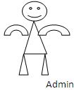

FIGURE 4.3: Use - Case Diagram

4.5.2 Class Diagram
In software engineering, a class diagram in the Unified Modeling Language (UML) is a type of static structure diagram that describes the structure of a system by showing the system's classes, their attributes, operations (or methods), and the relationships among the classes. It explains which class contains information.
Members
Members
Methods
Methods
Members
Methods
Methods
Members
Login, Train & Test YouTube Content Data Sets View Trained and Tested Accuracy in Bar Chart View Trained and Tested Accuracy Results View Prediction Of YouTube Content Data Sets View YouTube Content Data Sets Ratio Download Predicted Data Sets View YouTube Content Data Sets Ratio Results View All Remote Users

Video _id, title, channel_ title, category, publish_ time, content, views, likes, dislikes, comment_ count, Video_ link, publish_ date, views _per_ day,. Prediction

Service Provider
Login (), Reset (), Register ().

User Name, Password.
Login
Register (), Reset ()

User Name, Password, E-mail, Mobile, Address, DOB, Gender, Pin code, Image
Register
REGISTER AND LOGIN, PREDICT YOUTTUBE CONTENT TYPE,
VIEW YOUR PROFILE.

Video _id, title, channel_ title, category, publish_ time, content, views, likes, dislikes, comment_ count, Video_ link, publish_ date, views _per_ day,. Prediction
Remote User

Tweet Servervvv
Tweet Server
Tweet Server
Tweet Server
Tweet Server

FIGURE 4.4: Class Diagram

4.5.3 Sequential Diagram
A Sequence diagram in Unified Modeling Language (UML) is a kind of interaction diagram that shows how processes operate with one another and in what order. It is a construct of a Message Sequence Chart. Sequence diagrams are sometimes called event diagrams, event scenarios, and timing diagrams.

Service Provider
Remote User
Web Server

REGISTER AND LOGIN

PREDICT YOUTTUBE CONTENT TYPE,

VIEW YOUR PROFILE

Login,

Train & Test YouTube Content Data Sets

View Trained and Tested Accuracy in Bar Chart

View Trained and Tested Accuracy
Results
View Prediction Of YouTube Content
Data Sets

View YouTube Content Data Sets Ratio
Download Predicted Data Sets

View YouTube Content Data Sets Ratio Results

View All Remote Users

FIGURE 4.5: Sequential Diagram

4.5.4 Activity Diagram
Activity diagrams are graphical representations of workflows of stepwise activities and actions with support for choice, iteration and concurrency. In the Unified Modeling Language, activity diagrams can be used to describe the business and operational step-by-step workflows of components in a system. An activity diagram shows the overall flow of control.

Login
Start
Status
REGISTER AND LOGIN

Username & Password Wrong
PREDICT YOUTTUBE CONTENT TYPE
VIEW YOUR PROFILE
Logout
NO
YES

FIGURE 4.6(a): User Activity Diagram

Login
hvjjbjhbhjbhjgvhvhgvghvghvStatSSTATUSStatus
Train & Test YouTube Content Data Sets
Username & Password Wrong
Logout
View Prediction Of YouTube Content Data Sets
Download Predicted Data Sets
View Trained and Tested Accuracy Results
View Trained and Tested Accuracy in Bar Chart
Start
View YouTube Content Data Sets Ratio
View YouTube Content Data Sets Ratio Results
View All Remote Users
NO
YES
STATUSSSs

FIGURE 4.6(b) : Provider Activity Diagram

4.6 Conclusion
The system design phase has meticulously established a comprehensive and detailed blueprint for the inappropriate YouTube content detection system using deep learning, ensuring that the architecture is not only robust and scalable but also well-organized and capable of handling future expansions and modifications. The design process has been carefully structured to account for all possible functional and non-functional requirements, ensuring that the system is both efficient and adaptable to changes over time. A key aspect of this design phase is the strategic use of Unified Modeling Language (UML) diagrams, which play a crucial role in defining and organizing the system's structure and behavior. Various UML diagrams, including Data Flow Diagrams (DFDs), Use Case Diagrams, Class Diagrams, Sequence Diagrams, and Activity Diagrams, have been employed to capture the system's functional and structural aspects in a highly detailed and organized manner. The Data Flow Diagrams provide a clear and detailed representation of how data moves through the system, highlighting the inputs, processes, and outputs at each stage, thereby enabling a thorough understanding of the system's internal mechanics. Use Case Diagrams have been used to define the different actors involved in the system and the specific interactions they have with the system’s components, ensuring that all user scenarios are covered and well understood. Class Diagrams have been meticulously crafted to represent the static structure of the system, including the various classes, their attributes, methods, and the relationships between them, offering a precise map of the system’s core components and their interactions. Sequence Diagrams provide a dynamic view of the system by capturing the order of interactions between different objects over time, enabling developers to understand the flow of operations and how data is processed through the system in real-time. Activity Diagrams further enhance the understanding of the system's behavior by outlining the step-by-step flow of activities and decisions, ensuring that every possible scenario and workflow is accurately captured and well-organized. By leveraging these UML diagrams, the design phase has successfully created a structured and coherent framework for the inappropriate YouTube content detection system using deep learning, providing a clear and detailed view of the system's functionality, interactions, and data flow. These diagrams serve as essential tools for visualizing the components of the system and their relationships, enabling developers and stakeholders to gain a comprehensive understanding of the system's architecture and behavior. This detailed design ensures that the transition from design to implementation is seamless and efficient, minimizing the risk of errors and inconsistencies during the development phase. The structured approach to system design also facilitates easier debugging, testing, and future modifications, as the comprehensive documentation and diagrams provide a solid reference point for understanding the system's underlying structure and behavior. The inappropriate content detection system is designed to analyze video and audio streams using deep learning models, such as EfficientNet-B7 and BiLSTM, to identify and flag potentially harmful or inappropriate content. EfficientNet-B7, known for its high accuracy in image classification tasks, processes the video frames to detect visual elements that may be inappropriate, such as violence, nudity, or explicit content. BiLSTM is employed to analyze audio transcripts and contextual language patterns, identifying inappropriate speech, hate language, or other harmful verbal content. The combination of these models allows the system to perform multi-modal analysis, enhancing the accuracy and reliability of content detection. This meticulous design phase lays the foundation for a scalable and high-performance inappropriate content detection system for YouTube, capable of handling complex data processing requirements and providing accurate and reliable detection outcomes. Through careful planning and strategic use of UML diagrams, the design phase has ensured that the system is well-equipped to meet the demands of real-world use cases while maintaining flexibility for future enhancements and improvements.

CHAPTER 5
RESULTS AND ANALYSIS
5.1. Introduction
The Results and Analysis section evaluates the performance of the inappropriate content detection system using EfficientNet-B7 and BiLSTM on 1,860 minutes of annotated cartoon videos. Key metrics like accuracy, precision, recall, and F1-score measure effectiveness. The model, trained using TensorFlow and Keras, achieves 95.66% validation accuracy, outperforming traditional metadata-based filtering.
Comparative analysis highlights the superiority of video-based deep learning models in detecting inappropriate content. Challenges like dataset biases and false positives are examined, with future improvements including multimodal content analysis and dataset refinement. This section confirms the system’s efficiency and scalability in AI-driven content moderation, ensuring safer digital experiences for young viewers.
5.2 Explanation of key features
5.2.1. Python
Python is a general-purpose interpreted, interactive, object-oriented, and high-level programming language. An interpreted language, Python has a design philosophy that emphasizes code readability (notably using whitespace indentation to delimit code blocks rather than curly brackets or keywords), and a syntax that allows programmers to express concepts in fewer lines of code than might be used in languages such as C++or Java. It vprovides constructs that enable clear programming on both small and large scales. Python interpreters are available for many operating systems. CPython, the reference implementation of Python, is open source software and has a community-based development model, as do nearly all of its variant implementations. CPython is managed by the non-profit Python Software Foundation. Python features a dynamic type system and automatic memory management. It supports multiple programming paradigms, including object-oriented, imperative, functional and procedural, and has a large and comprehensive standard library.
Interactive Mode Programming:
Invoking the interpreter without passing a script file as a parameter brings up the following prompt −
$ python
Python 2.4.3 (#1, Nov 11 2010, 13:34:43)
[GCC 4.1.2 20080704 (Red Hat 4.1.2-48)] on linux2
Type "help", "copyright", "credits" or "license" for more information.
>>>
Type the following text at the Python prompt and press the Enter −
>>> print "Hello, Python!"
If you are running new version of Python, then you would need to use print statement with parenthesis as in print ("Hello, Python!");. However in Python version 2.4.3, this produces the following result −
Hello, Python!
Script Mode Programming:
Invoking the interpreter with a script parameter begins execution of the script and continues until the script is finished. When the script is finished, the interpreter is no longer active.
Let us write a simple Python program in a script. Python files have extension .py. Type the following source code in a test.py file −
print "Hello, Python!"
We assume that you have Python interpreter set in PATH variable. Now, try to run this program as follows −
$ python test.py
This produces the following result −
Hello, Python!
Let us try another way to execute a Python script. Here is the modified test.py file −
#!/usr/bin/python
print "Hello, Python!"
We assume that you have Python interpreter available in /usr/bin directory. Now, try to run this program as follows −
$ chmod +x test.py # This is to make file executable
$./test.py
This produces the following result
−Hello, Python!
Python Identifiers:
A Python identifier is a name used to identify a variable, function, class, module or other object. An identifier starts with a letter A to Z or a to z or an underscore (_) followed by zero or more letters, underscores and digits (0 to 9).
Python does not allow punctuation characters such as @, $, and % within identifiers. Python is a case sensitive programming language. Thus, Manpower and manpower are two different identifiers in Python.
Here are naming conventions for Python identifiers −
Class names start with an uppercase letter. All other identifiers start with a lowercase letter. Starting an identifier with a single leading underscore indicates that the identifier is private. Starting an identifier with two leading underscores indicates a strongly private identifier. If the identifier also ends with two trailing underscores, the identifier is a language-defined special name.
Reserved Words:
The following list shows the Python keywords. These are reserved words and you cannot use them as constant or variable or any other identifier names. All the Python keywords contain lowercase letters only.
and exec not
assert finally or
break for pass
class from print
continue global raise
def if return
del import try
elif in while
else is with
except lambda yield
Lines and Indentation:
Python provides no braces to indicate blocks of code for class and function definitions or flow control. Blocks of code are denoted by line indentation, which is rigidly enforced.
The number of spaces in the indentation is variable, but all statements within the block must be indented the same amount. For example −
if True:
print "True"
else:
print "False"
However, the following block generates an error −
if True:
print "Answer"
print "True"
else:
print "Answer"
print "False"
Thus, in Python all the continuous lines indented with same number of spaces would form a block. The following example has various statement blocks −
Note − Do not try to understand the logic at this point of time. Just make sure you understood various blocks even if they are without braces.
#!/usr/bin/python
import sys
try:
# open file stream
file = open(file_name, "w")
except IOError:
print "There was an error writing to", file_name
sys.exit()
print "Enter '", file_finish,
print "' When finished"
while file_text != file_finish:
file_text = raw_input("Enter text: ")
if file_text == file_finish:
# close the file
file.close
break
file.write(file_text)
file.write("\n")
file.close()
file_name = raw_input("Enter filename: ")
if len(file_name) == 0:
print "Next time please enter something"
sys.exit()
try:
file = open(file_name, "r")
except IOError:
print "There was an error reading file"
sys.exit()
file_text = file.read()
file.close()
print file_text
Multi-Line Statements
Statements in Python typically end with a new line. Python does, however, allow the use of the line continuation character (\) to denote that the line should continue. For example
total = item_one + \
item_two + \
item_three
Statements contained within the [], {}, or () brackets do not need to use the line continuation character. For example −
days = ['Monday', 'Tuesday', 'Wednesday',
'Thursday', 'Friday']
Quotation in Python
Python accepts single ('), double (") and triple (''' or """) quotes to denote string literals, as long as the same type of quote starts and ends the string.
The triple quotes are used to span the string across multiple lines. For example, all the following are legal −
word = 'word'
sentence = "This is a sentence."
paragraph = """This is a paragraph. It is
made up of multiple lines and sentences."""
A hash sign (#) that is not inside a string literal begins a comment. All characters after the # and up to the end of the physical line are part of the comment and the Python interpreter ignores them.
#!/usr/bin/python
# First comment
print "Hello, Python!" # second comment
This produces the following result −
Hello, Python!
You can type a comment on the same line after a statement or expression −
name = "Madisetti" # This is again comment
You can comment multiple lines as follows −
# This is a comment.
# This is a comment, too.
# This is a comment, too.
# I said that already.
Following triple-quoted string is also ignored by Python interpreter and can be used as a multiline comments:
'''
This is a multiline
comment.
'''
A line containing only whitespace, possibly with a comment, is known as a blank line and Python totally ignores it.
In an interactive interpreter session, you must enter an empty physical line to terminate a multiline statement.
The following line of the program displays the prompt, the statement saying “Press the enter key to exit”, and waits for the user to take action −
#!/usr/bin/python
raw_input("\n\nPress the enter key to exit.")
Here, "\n\n" is used to create two new lines before displaying the actual line. Once the user presses the key, the program ends. This is a nice trick to keep a console window open until the user is done with an application.
Multiple Statements on a Single Line:
The semicolon ( ; ) allows multiple statements on the single line given that neither statement starts a new code block. Here is a sample snip using the semicolon.
import sys; x = 'foo'; sys.stdout.write(x + '\n')
Multiple Statement Groups as Suites:
A group of individual statements, which make a single code block are called suites in Python. Compound or complex statements, such as if, while, def, and class require a header line and a suite.
Header lines begin the statement (with the keyword) and terminate with a colon ( : ) and are followed by one or more lines which make up the suite. For example −
if expression :
suite
elif expression :
suite
else :
suite
Command Line Arguments:
Many programs can be run to provide you with some basic information about how they should be run. Python enables you to do this with -h −
$ python -h
usage: python [option] ... [-c cmd | -m mod | file | -] [arg] ...
Options and arguments (and corresponding environment variables):
-c cmd : program passed in as string (terminates option list)
-d : debug output from parser (also PYTHONDEBUG=x)
-E : ignore environment variables (such as PYTHONPATH)
-h : print this help message and exit
You can also program your script in such a way that it should accept various options. Command Line Arguments is an advanced topic and should be studied a bit later once you have gone through rest of the Python concepts.
Python Lists:
The list is a most versatile datatype available in Python which can be written as a list of comma-separated values (items) between square brackets. Important thing about a list is that items in a list need not be of the same type.
Creating a list is as simple as putting different comma-separated values between square brackets. For example −
list1 = ['physics', 'chemistry', 1997, 2000];
list2 = [1, 2, 3, 4, 5 ];
list3 = ["a", "b", "c", "d"]
Similar to string indices, list indices start at 0, and lists can be sliced, concatenated and so on.
A tuple is a sequence of immutable Python objects. Tuples are sequences, just like lists. The differences between tuples and lists are, the tuples cannot be changed unlike lists and tuples use parentheses, whereas lists use square brackets.
Creating a tuple is as simple as putting different comma-separated values. Optionally you can put these comma-separated values between parentheses also. For example −
tup1 = ('physics', 'chemistry', 1997, 2000);
tup2 = (1, 2, 3, 4, 5 );
tup3 = "a", "b", "c", "d";
The empty tuple is written as two parentheses containing nothing −
tup1 = ();
To write a tuple containing a single value you have to include a comma, even though there is only one value −
tup1 = (50,);
Like string indices, tuple indices start at 0, and they can be sliced, concatenated, and so on.
Accessing Values in Tuples:
To access values in tuple, use the square brackets for slicing along with the index or indices to obtain value available at that index. For example −
#!/usr/bin/python
tup1 = ('physics', 'chemistry', 1997, 2000);
tup2 = (1, 2, 3, 4, 5, 6, 7 );
print "tup1[0]: ", tup1[0];
print "tup2[1:5]: ", tup2[1:5];
When the above code is executed, it produces the following result −
tup1[0]: physics
tup2[1:5]: [2, 3, 4, 5]
Updating Tuples:
To access dictionary elements, you can use the familiar square brackets along with the key to obtain its value. Following is a simple example –
#!/usr/bin/python
dict = {'Name': 'Zara', 'Age': 7, 'Class': 'First'}
print "dict['Name']: ", dict['Name']
print "dict['Age']: ", dict['Age']
When the above code is executed, it produces the following result −
dict['Name']: Zara
dict['Age']: 7
If we attempt to access a data item with a key, which is not part of the dictionary, we get an error as follows −
#!/usr/bin/python
dict = {'Name': 'Zara', 'Age': 7, 'Class': 'First'}
print "dict['Alice']: ", dict['Alice']
When the above code is executed, it produces the following result −
dict['Alice']:
Traceback (most recent call last):
File "test.py", line 4, in <module>
print "dict['Alice']: ", dict['Alice'];
KeyError: 'Alice'
You can update a dictionary by adding a new entry or a key-value pair, modifying an existing entry, or deleting an existing entry as shown below in the simple example −
#!/usr/bin/python
dict = {'Name': 'Zara', 'Age': 7, 'Class': 'First'}
dict['Age'] = 8; # update existing entry
dict['School'] = "DPS School"; # Add new entry
print "dict['Age']: ", dict['Age']
print "dict['School']: ", dict['School']
When the above code is executed, it produces the following result −
dict['Age']: 8
dict['School']: DPS School
Delete Dictionary Elements:
You can either remove individual dictionary elements or clear the entire contents of a dictionary. You can also delete entire dictionary in a single operation.
To explicitly remove an entire dictionary, just use the del statement. Following is a simple example −
#!/usr/bin/python
dict = {'Name': 'Zara', 'Age': 7, 'Class': 'First'}
del dict['Name']; # remove entry with key 'Name'
dict.clear(); # remove all entries in dict
del dict ; # delete entire dictionary
print "dict['Age']: ", dict['Age']
print "dict['School']: ", dict['School']
This produces the following result. Note that an exception is raised because after del dict dictionary does not exist any more −
dict['Age']:
Traceback (most recent call last):
File "test.py", line 8, in <module>
print "dict['Age']: ", dict['Age'];
TypeError: 'type' object is unsubscriptable
Note − del() method is discussed in subsequent section.
Properties of Dictionary Keys:
Dictionary values have no restrictions. They can be any arbitrary Python object, either standard objects or user-defined objects. However, same is not true for the keys.
There are two important points to remember about dictionary keys −
(a) More than one entry per key not allowed. Which means no duplicate key is allowed. When duplicate keys encountered during assignment, the last assignment wins. For example −
#!/usr/bin/python
dict = {'Name': 'Zara', 'Age': 7, 'Name': 'Manni'}
print "dict['Name']: ", dict['Name']
When the above code is executed, it produces the following result −
dict['Name']: Manni
(b) Keys must be immutable. Which means you can use strings, numbers or tuples as dictionary keys but something like ['key'] is not allowed. Following is a simple example −
#!/usr/bin/python
dict = {['Name']: 'Zara', 'Age': 7}
print "dict['Name']: ", dict['Name']
When the above code is executed, it produces the following result −
Traceback (most recent call last):
File "test.py", line 3, in <module>
dict = {['Name']: 'Zara', 'Age': 7};
TypeError: unhashable type: 'list'
Tuples are immutable which means you cannot update or change the values of tuple elements. You are able to take portions of existing tuples to create new tuples as the following example demonstrates −
#!/usr/bin/python
tup1 = (12, 34.56);
tup2 = ('abc', 'xyz');
# Following action is not valid for tuples
# tup1[0] = 100;
# So let's create a new tuple as follows
tup3 = tup1 + tup2;
print tup3;
When the above code is executed, it produces the following result −
(12, 34.56, 'abc', 'xyz')
Delete Tuple Elements:
Removing individual tuple elements is not possible. There is, of course, nothing wrong with putting together another tuple with the undesired elements discarded.
To explicitly remove an entire tuple, just use the del statement. For example −
#!/usr/bin/python
tup = ('physics', 'chemistry', 1997, 2000);
print tup;
del tup;
print "After deleting tup : ";
print tup;
This produces the following result. Note an exception raised, this is because after del tup tuple does not exist any more −
('physics', 'chemistry', 1997, 2000)
After deleting tup :
Traceback (most recent call last):
File "test.py", line 9, in <module>
print tup;
NameError: name 'tup' is not defined
5.2.2.Django
Django is a high-level Python Web framework that encourages rapid development and clean, pragmatic design. Built by experienced developers, it takes care of much of the hassle of Web development, so you can focus on writing your app without needing to reinvent the wheel.
View
Template
Model
URL

FIGURE 5.1: Django Architecture
FIGURE 5.2: Django Working Mechanism
Create a Project:
Whether you are on Windows or Linux, just get a terminal or a cmd prompt and navigate to the place you want your project to be created, then use this code −
$ django-admin startproject myproject
Web Browser
Database
Model
View
Template
URL Dispatcher
Catching Framework
This will create a "myproject" folder with the following structure −
myproject/
manage.py
myproject/
__init__.py
settings.py
urls.py
wsgi.py
The “myproject” folder is just your project container, it actually contains two elements
manage.py − This file is kind of your project local django-admin for interacting with your project via command line (start the development server, sync db...). To get a full list of command accessible via manage.py you can use the code −
$ python manage.py help
The “myproject” subfolder − This folder is the actual python package of your project. It contains four files −
__init__.py − Just for python, treat this folder as package.
settings.py − As the name indicates, your project settings.
urls.py − All links of your project and the function to call. A kind of ToC of your project.
wsgi.py − If you need to deploy your project over WSGI.
Setting Up Your Project
Your project is set up in the subfolder myproject/settings.py. Following are some important options you might need to set −
DEBUG = True
This option lets you set if your project is in debug mode or not. Debug mode lets you get more information about your project's error. Never set it to ‘True’ for a live project. However, this has to be set to ‘True’ if you want the Django light server to serve static files. Do it only in the development mode.
DATABASES = {
'default': {
'ENGINE': 'django.db.backends.sqlite3',
'NAME': 'database.sql',
'USER': '',
'PASSWORD': '',
'HOST': '',
'PORT': '',
}
}
Database is set in the ‘Database’ dictionary. The example above is for SQLite engine. As stated earlier, Django also supports −
MySQL (django.db.backends.mysql)
PostGreSQL (django.db.backends.postgresql_psycopg2)
Oracle (django.db.backends.oracle) and NoSQL DB
MongoDB (django_mongodb_engine)
Before setting any new engine, make sure you have the correct db driver installed.
You can also set others options like: TIME_ZONE, LANGUAGE_CODE, TEMPLATE…
Now that your project is created and configured make sure it's working −
$ python manage.py runserver
You will get something like the following on running the above code −
Validating models...
0 errors found
September 03, 2015 - 11:41:50
Django version 1.6.11, using settings 'myproject.settings'
Starting development server at http://127.0.0.1:8000/
Quit the server with CONTROL-C.
A project is a sum of many applications. Every application has an objective and can be reused into another project, like the contact form on a website can be an application, and can be reused for others. See it as a module of your project.
Create an Application:
We assume you are in your project folder. In our main “myproject” folder, the same folder then manage.py −
$ python manage.py startapp myapp
You just created myapp application and like project, Django create a “myapp” folder with the application structure −
myapp/
__init__.py
admin.py
models.py
tests.py
views.py
__init__.py − Just to make sure python handles this folder as a package.
admin.py − This file helps you make the app modifiable in the admin interface.
models.py − This is where all the application models are stored.
tests.py − This is where your unit tests are.
views.py − This is where your application views are.
Get the Project to Know About Your Application
At this stage we have our "myapp" application, now we need to register it with our Django project "myproject". To do so, update INSTALLED_APPS tuple in the settings.py file of your project (add your app name) −
INSTALLED_APPS = (
'django.contrib.admin',
'django.contrib.auth',
'django.contrib.contenttypes',
'django.contrib.sessions',
'django.contrib.messages',
'django.contrib.staticfiles',
'myapp',
)
Creating forms in Django, is really similar to creating a model. Here again, we just need to inherit from Django class and the class attributes will be the form fields. Let's add a forms.py file in myapp folder to contain our app forms. We will create a login form.
myapp/forms.py
#-*- coding: utf-8 -*-
from django import forms
class LoginForm(forms.Form):
user = forms.CharField(max_length = 100)
password = forms.CharField(widget = forms.PasswordInput())
As seen above, the field type can take "widget" argument for html rendering; in our case, we want the password to be hidden, not displayed. Many others widget are present in Django: DateInput for dates, CheckboxInput for checkboxes, etc.
Using Form in a View:
There are two kinds of HTTP requests, GET and POST. In Django, the request object passed as parameter to your view has an attribute called "method" where the type of the request is set, and all data passed via POST can be accessed via the request.POST dictionary.
Let's create a login view in our myapp/views.py –
#-*- coding: utf-8 -*-
from myapp.forms import LoginForm
def login(request):
username = "not logged in"
if request.method == "POST":
#Get the posted form
MyLoginForm = LoginForm(request.POST)
if MyLoginForm.is_valid():
username = MyLoginForm.cleaned_data['username']
else:
MyLoginForm = Loginform()
return render(request, 'loggedin.html', {"username" : username})
The view will display the result of the login form posted through the loggedin.html. To test it, we will first need the login form template. Let's call it login.html.
<html>
<body>
<form name = "form" action = "{% url "myapp.views.login" %}"
method = "POST" >{% csrf_token %}
<div style = "max-width:470px;">
<center>
<input type = "text" style = "margin-left:20%;"
placeholder = "Identifiant" name = "username" />
</center>
</div>
<br>
<div style = "max-width:470px;">
<center>
<input type = "password" style = "margin-left:20%;"
placeholder = "password" name = "password" />
</center>
</div>
<br>
<div style = "max-width:470px;">
<center>
<input type = "text" style = "margin-left:20%;"
placeholder = "Identifiant" name = "username" />
</center>
</div>
<br>
<div style = "max-width:470px;">
<center>
<button style = "border:0px; background-color:#4285F4; margin-top:8%;
height:35px; width:80%;margin-left:19%;" type = "submit"
value = "Login" >
<strong>Login</strong>
</button>
</center>
</div>
<div style = "max-width:470px;">
<center>
<input type = "password" style = "margin-left:20%;"
placeholder = "password" name = "password" />
</center>
</div>
<br>
<div style = "max-width:470px;">
<center>
<input type = "text" style = "margin-left:20%;"
placeholder = "Identifiant" name = "username" />
</center>
</div>
<br>
<div style = "max-width:470px;">
<center>
<button style = "border:0px; background-color:#4285F4; margin-top:8%;
height:35px; width:80%;margin-left:19%;" type = "submit"
value = "Login" >
<strong>Login</strong>
</button>
</center>
</div>
</form>
</body>
</html>
The template will display a login form and post the result to our login view above. You have probably noticed the tag in the template, which is just to prevent Cross-site Request Forgery (CSRF) attack on your site.
{% csrf_token %}
Once we have the login template, we need the loggedin.html template that will be rendered after form treatment.
<html>
<body>
You are : <strong>{{username}}</strong>
</body>
</html>
Now, we just need our pair of URLs to get started: myapp/urls.py
from django.conf.urls import patterns, url
from django.views.generic import TemplateView
urlpatterns = patterns('myapp.views',
url(r'^connection/',TemplateView.as_view(template_name = 'login.html')),
url(r'^login/', 'login', name = 'login'))
When accessing "/myapp/connection", we will get the following login.html template rendered −
Setting Up Sessions
In Django, enabling session is done in your project settings.py, by adding some lines to the MIDDLEWARE_CLASSES and the INSTALLED_APPS options. This should be done while creating the project, but it's always good to know, so MIDDLEWARE_CLASSES should have −
'django.contrib.sessions.middleware.SessionMiddleware'
And INSTALLED_APPS should have −
'django.contrib.sessions'
By default, Django saves session information in database (django_session table or collection), but you can configure the engine to store information using other ways like: in file or in cache.
When session is enabled, every request (first argument of any view in Django) has a session (dict) attribute.
Let's create a simple sample to see how to create and save sessions. We have built a simple login system before (see Django form processing chapter and Django Cookies Handling chapter). Let us save the username in a cookie so, if not signed out, when accessing our login page you won’t see the login form. Basically, let's make our login system we used in Django Cookies handling more secure, by saving cookies server side.
For this, first lets change our login view to save our username cookie server side −
def login(request):
username = 'not logged in'
if request.method == 'POST':
MyLoginForm = LoginForm(request.POST)
if MyLoginForm.is_valid():
username = MyLoginForm.cleaned_data['username']
request.session['username'] = username
else:
MyLoginForm = LoginForm()
return render(request, 'loggedin.html', {"username" : username}
Then let us create formView view for the login form, where we won’t display the form if cookie is set −
def formView(request):
if request.session.has_key('username'):
username = request.session['username']
return render(request, 'loggedin.html', {"username" : username})
else:
return render(request, 'login.html', {})
Now let us change the url.py file to change the url so it pairs with our new view −
from django.conf.urls import patterns, url
from django.views.generic import TemplateView
urlpatterns = patterns('myapp.views',
url(r'^connection/','formView', name = 'loginform'),
url(r'^login/', 'login', name = 'login'))
When accessing /myapp/connection, you will get to see the following page

5.3. Method of Implementation:

5.3.1. Source Code:

Manage.py

#!/usr/bin/env python
"""Django's command-line utility for administrative tasks."""
import os
import sys

def main():
"""Run administrative tasks."""
os.environ.setdefault('DJANGO_SETTINGS_MODULE', 'content_detection_and_classification_of_youtube_videos.settings')
try:
from django.core.management import execute_from_command_line
except ImportError as exc:
raise ImportError(
"Couldn't import Django. Are you sure it's installed and "
"available on your PYTHONPATH environment variable? Did you "
"forget to activate a virtual environment?"
) from exc
execute_from_command_line(sys.argv)

if __name__ == '__main__':
main()
Service Provider-> Models.py:
from django.db import models

# Create your models here.
from django.db.models import CASCADE

class ClientRegister_Model(models.Model):
username = models.CharField(max_length=30)
email = models.EmailField(max_length=30)
password = models.CharField(max_length=10)
phoneno = models.CharField(max_length=10)
country = models.CharField(max_length=30)
state = models.CharField(max_length=30)
city = models.CharField(max_length=30)
gender= models.CharField(max_length=30)
address= models.CharField(max_length=30)

class content_detection_type(models.Model):

video_id= models.CharField(max_length=3000)
title= models.CharField(max_length=3000)
channel_title= models.CharField(max_length=3000)
category= models.CharField(max_length=3000)
publish_time= models.CharField(max_length=3000)
content= models.CharField(max_length=30000)
views= models.CharField(max_length=3000)
likes= models.CharField(max_length=3000)
dislikes= models.CharField(max_length=3000)
comment_count= models.CharField(max_length=3000)
Video_link= models.CharField(max_length=3000)
publish_date= models.CharField(max_length=3000)
views_per_day= models.CharField(max_length=3000)
Prediction= models.CharField(max_length=3000)

class detection_accuracy(models.Model):

names = models.CharField(max_length=300)
ratio = models.CharField(max_length=300)

class detection_ratio(models.Model):

names = models.CharField(max_length=300)
ratio = models.CharField(max_length=300)
Remote User->forms.py:
from django import forms

from Remote_User.models import ClientRegister_Model

class ClientRegister_Form(forms.ModelForm):
password = forms.CharField(widget=forms.PasswordInput())
email = forms.EmailField(required=True)

class Meta:
model = ClientRegister_Model
fields = ("username","email","password","phoneno","country","state","city")

ServiceProvider->views.py:

from django.db.models import Count, Avg
from django.shortcuts import render, redirect
from django.db.models import Count
from django.db.models import Q
import datetime
import xlwt
from django.http import HttpResponse

import pandas as pd
from sklearn.feature_extraction.text import CountVectorizer
from sklearn.metrics import accuracy_score, confusion_matrix, classification_report
from sklearn.metrics import accuracy_score
from sklearn.tree import DecisionTreeClassifier

# Create your views here.
from Remote_User.models import ClientRegister_Model,content_detection_type,detection_ratio,detection_accuracy

def serviceproviderlogin(request):
if request.method == "POST":
admin = request.POST.get('username')
password = request.POST.get('password')
if admin == "Admin" and password =="Admin":
detection_accuracy.objects.all().delete()
return redirect('View_Remote_Users')

return render(request,'SProvider/serviceproviderlogin.html')

def View_Prediction_Of_YouTube_Content_Ratio(request):
detection_ratio.objects.all().delete()
ratio = ""
kword = 'True Content'
print(kword)
obj = content_detection_type.objects.all().filter(Q(Prediction=kword))
obj1 = content_detection_type.objects.all()
count = obj.count();
count1 = obj1.count();
ratio = (count / count1) * 100
if ratio != 0:
detection_ratio.objects.create(names=kword, ratio=ratio)

ratio12 = ""
kword12 = 'False Content'
print(kword12)
obj12 = content_detection_type.objects.all().filter(Q(Prediction=kword12))
obj112 = content_detection_type.objects.all()
count12 = obj12.count();
count112 = obj112.count();
ratio12 = (count12 / count112) * 100
if ratio12 != 0:
detection_ratio.objects.create(names=kword12, ratio=ratio12)

obj = detection_ratio.objects.all()
return render(request, 'SProvider/View_Prediction_Of_YouTube_Content_Ratio.html', {'objs': obj})

def View_Remote_Users(request):
obj=ClientRegister_Model.objects.all()
return render(request,'SProvider/View_Remote_Users.html',{'objects':obj})

def charts(request,chart_type):
chart1 = detection_ratio.objects.values('names').annotate(dcount=Avg('ratio'))
return render(request,"SProvider/charts.html", {'form':chart1, 'chart_type':chart_type})

def charts1(request,chart_type):
chart1 = detection_accuracy.objects.values('names').annotate(dcount=Avg('ratio'))
return render(request,"SProvider/charts1.html", {'form':chart1, 'chart_type':chart_type})

def View_Prediction_Of_YouTube_Content_Type(request):
obj =content_detection_type.objects.all()
obj12 = content_detection_type.objects.all().filter(Q(Prediction=kword12))
obj112 = content_detection_type.objects.all()
count12 = obj12.count();
count112 = obj112.count();
ratio12 = (count12 / count112) * 100

return render(request, 'SProvider/View_Prediction_Of_YouTube_Content_Type.html', {'list_objects': obj})

def likeschart(request,like_chart):
charts =detection_accuracy.objects.values('names').annotate(dcount=Avg('ratio'))
return render(request,"SProvider/likeschart.html", {'form':charts, 'like_chart':like_chart})
obj = detection_ratio.objects.all()
return render(request, 'SProvider/View_Prediction_Of_YouTube_Content_Ratio.html', {'objs': obj})

def View_Remote_Users(request):
obj=ClientRegister_Model.objects.all()
return render(request,'SProvider/View_Remote_Users.html',{'objects':obj})

def charts(request,chart_type):
chart1 = detection_ratio.objects.values('names').annotate(dcount=Avg('ratio'))
return render(request,"SProvider/charts.html", {'form':chart1, 'chart_type':chart_type})

def charts1(request,chart_type):
chart1 = detection_accuracy.objects.values('names').annotate(dcount=Avg('ratio'))
return render(request,"SProvider/charts1.html", {'form':chart1, 'chart_type':chart_type})

def Download_Trained_DataSets(request):

response = HttpResponse(content_type='application/ms-excel')
# decide file name
response['Content-Disposition'] = 'attachment; filename="Predicted_Datasets.xls"'
# creating workbook
wb = xlwt.Workbook(encoding='utf-8')
# adding sheet
ws = wb.add_sheet("sheet1")
# Sheet header, first row
row_num = 0
font_style = xlwt.XFStyle()
# headers are bold
font_style.font.bold = True
# writer = csv.writer(response)
obj = content_detection_type.objects.all()
data = obj # dummy method to fetch data.
for my_row in data:
row_num = row_num + 1

ws.write(row_num, 0, my_row.video_id, font_style)
ws.write(row_num, 1, my_row.title, font_style)
ws.write(row_num, 2, my_row.channel_title, font_style)
ws.write(row_num, 3, my_row.category, font_style)
ws.write(row_num, 4, my_row.publish_time, font_style)
ws.write(row_num, 5, my_row.content, font_style)
ws.write(row_num, 6, my_row.views, font_style)
ws.write(row_num, 7, my_row.likes, font_style)
ws.write(row_num, 8, my_row.dislikes, font_style)
ws.write(row_num, 9, my_row.comment_count, font_style)
ws.write(row_num, 10, my_row.Video_link, font_style)
ws.write(row_num, 11, my_row.publish_date, font_style)
ws.write(row_num, 12, my_row.views_per_day, font_style)
ws.write(row_num, 14, my_row.Prediction, font_style)
ws.write(row_num, 15, my_row.channel_title, font_style)
ws.write(row_num, 16, my_row.category, font_style)
ws.write(row_num, 17, my_row.publish_time, font_style)
ws.write(row_num, 18, my_row.content, font_style)
ws.write(row_num, 19, my_row.views, font_style)
ws.write(row_num, 20, my_row.likes, font_style)
ws.write(row_num, 21, my_row.dislikes, font_style)
ws.write(row_num, 22, my_row.comment_count, font_style)
ws.write(row_num, 23, my_row.Video_link, font_style)
ws.write(row_num, 24, my_row.publish_date, font_style)
ws.write(row_num, 25, my_row.views_per_day, font_style)
ws.write(row_num, 26, my_row.Prediction, font_style)

wb.save(response)
return response

def train_model(request):
detection_accuracy.objects.all().delete()

df = pd.read_csv('Datasets.csv')

def apply_response(Label):
if (Label== 0):
return 0 # True Content
elif (Label==1):
return 1 # False Content

df['results'] = df['Label'].apply(apply_response)

cv = CountVectorizer()
X = df['content']
y = df['results']

print("Contents")
print(X)
print("Results")
print(y)

X = cv.fit_transform(X)

models = []
from sklearn.model_selection import train_test_split
X_train, X_test, y_train, y_test = train_test_split(X, y, test_size=0.20)
X_train.shape, X_test.shape, y_train.shape

print(X_test)

print("Naive Bayes")

from sklearn.naive_bayes import MultinomialNB
NB = MultinomialNB()
NB.fit(X_train, y_train)
predict_nb = NB.predict(X_test)
naivebayes = accuracy_score(y_test, predict_nb) * 100
print(naivebayes)
print(confusion_matrix(y_test, predict_nb))
print(classification_report(y_test, predict_nb))
models.append(('naive_bayes', NB))
detection_accuracy.objects.create(names="Naive Bayes", ratio=naivebayes)

# SVM Model
print("SVM")
from sklearn import svm
lin_clf = svm.LinearSVC()
lin_clf.fit(X_train, y_train)
predict_svm = lin_clf.predict(X_test)
svm_acc = accuracy_score(y_test, predict_svm) * 100
print(svm_acc)
print("CLASSIFICATION REPORT")
print(classification_report(y_test, predict_svm))
print("CONFUSION MATRIX")
print(confusion_matrix(y_test, predict_svm))
models.append(('svm', lin_clf))
detection_accuracy.objects.create(names="SVM", ratio=svm_acc)

print("Logistic Regression")

from sklearn.linear_model import LogisticRegression
reg = LogisticRegression(random_state=0, solver='lbfgs').fit(X_train, y_train)
y_pred = reg.predict(X_test)
print("ACCURACY")
print(accuracy_score(y_test, y_pred) * 100)
print("CLASSIFICATION REPORT")
print(classification_report(y_test, y_pred))
print("CONFUSION MATRIX")
print(confusion_matrix(y_test, y_pred))
models.append(('logistic', reg))
detection_accuracy.objects.create(names="Logistic Regression", ratio=accuracy_score(y_test, y_pred) * 100)

print("Decision Tree Classifier")
dtc = DecisionTreeClassifier()
dtc.fit(X_train, y_train)
dtcpredict = dtc.predict(X_test)
print("ACCURACY")
print(accuracy_score(y_test, dtcpredict) * 100)
print("CLASSIFICATION REPORT")
print(classification_report(y_test, dtcpredict))
print("CONFUSION MATRIX")
print(confusion_matrix(y_test, dtcpredict))
models.append(('DecisionTreeClassifier', dtc))
detection_accuracy.objects.create(names="Decision Tree Classifier", ratio=accuracy_score(y_test, dtcpredict) * 100)

csv_format = 'Results.csv'
df.to_csv(csv_format, index=False)
df.to_markdown

obj = detection_accuracy.objects.all()
return render(request,'SProvider/train_model.html', {'objs': obj})

Remote User->views.py:
from django.db.models import Count
from django.db.models import Q
from django.shortcuts import render, redirect, get_object_or_404

import pandas as pd
from sklearn.feature_extraction.text import CountVectorizer
from sklearn.metrics import accuracy_score, confusion_matrix, classification_report
from sklearn.metrics import accuracy_score
from sklearn.tree import DecisionTreeClassifier
from sklearn.ensemble import VotingClassifier
# Create your views here.
from Remote_User.models import ClientRegister_Model,content_detection_type,detection_ratio,detection_accuracy

def login(request):

if request.method == "POST" and 'submit1' in request.POST:

username = request.POST.get('username')
password = request.POST.get('password')
try:
enter = ClientRegister_Model.objects.get(username=username,password=password)
request.session["userid"] = enter.id

return redirect('ViewYourProfile')
except:
pass

return render(request,'RUser/login.html')

def index(request):
return render(request, 'RUser/index.html')

def Add_DataSet_Details(request):

return render(request, 'RUser/Add_DataSet_Details.html', {"excel_data": ''})

def Register1(request):

if request.method == "POST":
username = request.POST.get('username')
email = request.POST.get('email')
password = request.POST.get('password')
phoneno = request.POST.get('phoneno')
country = request.POST.get('country')
state = request.POST.get('state')
city = request.POST.get('city')
address = request.POST.get('address')
gender = request.POST.get('gender')
ClientRegister_Model.objects.create(username=username, email=email, password=password, phoneno=phoneno,
country=country, state=state, city=city,address=address,gender=gender)

obj = "Registered Successfully"
return render(request, 'RUser/Register1.html',{'object':obj})
else:
return render(request,'RUser/Register1.html')

def ViewYourProfile(request):
userid = request.session['userid']
obj = ClientRegister_Model.objects.get(id= userid)
return render(request,'RUser/ViewYourProfile.html',{'object':obj})

def Predict_YouTube_Content_Type(request):
if request.method == "POST":

if request.method == "POST":

video_id= request.POST.get('video_id')
title= request.POST.get('title')
channel_title= request.POST.get('channel_title')
category= request.POST.get('category')
publish_time= request.POST.get('publish_time')
content= request.POST.get('content')
views= request.POST.get('views')
likes= request.POST.get('likes')
dislikes= request.POST.get('dislikes')
comment_count= request.POST.get('comment_count')
Video_link= request.POST.get('Video_link')
publish_date= request.POST.get('publish_date')
views_per_day= request.POST.get('views_per_day')

df = pd.read_csv('Datasets.csv')

def apply_response(Label):
if (Label == 0):
return 0 # True Content
elif (Label == 1):
return 1 # False Content

df['results'] = df['Label'].apply(apply_response)

cv = CountVectorizer()
X = df['content']
y = df['results']

print("Contents")
print(X)
print("Results")
print(y)

X = cv.fit_transform(X)
models = []
from sklearn.model_selection import train_test_split
X_train, X_test, y_train, y_test = train_test_split(X, y, test_size=0.20)
X_train.shape, X_test.shape, y_train.shape

print("Naive Bayes")

from sklearn.naive_bayes import MultinomialNB

NB = MultinomialNB()
NB.fit(X_train, y_train)
predict_nb = NB.predict(X_test)
naivebayes = accuracy_score(y_test, predict_nb) * 100
print("ACCURACY")
print(naivebayes)
print("CLASSIFICATION REPORT")
print(classification_report(y_test, predict_nb))
print("CONFUSION MATRIX")
print(confusion_matrix(y_test, predict_nb))
models.append(('naive_bayes', NB))

# SVM Model
print("SVM")
from sklearn import svm

lin_clf = svm.LinearSVC()
lin_clf.fit(X_train, y_train)
predict_svm = lin_clf.predict(X_test)
svm_acc = accuracy_score(y_test, predict_svm) * 100
print("ACCURACY")
print(svm_acc)
print("CLASSIFICATION REPORT")
print(classification_report(y_test, predict_svm))
print("CONFUSION MATRIX")
print(confusion_matrix(y_test, predict_svm))
models.append(('svm', lin_clf))

print("Logistic Regression")

from sklearn.linear_model import LogisticRegression

reg = LogisticRegression(random_state=0, solver='lbfgs').fit(X_train, y_train)
y_pred = reg.predict(X_test)
print("ACCURACY")
print(accuracy_score(y_test, y_pred) * 100)
print("CLASSIFICATION REPORT")
print(classification_report(y_test, y_pred))
print("CONFUSION MATRIX")
print(confusion_matrix(y_test, y_pred))
models.append(('logistic', reg))

print("Decision Tree Classifier")
dtc = DecisionTreeClassifier()
dtc.fit(X_train, y_train)
dtcpredict = dtc.predict(X_test)
print("ACCURACY")
print(accuracy_score(y_test, dtcpredict) * 100)
print("CLASSIFICATION REPORT")
print(classification_report(y_test, dtcpredict))
print("CONFUSION MATRIX")
print(confusion_matrix(y_test, dtcpredict))
models.append(('DecisionTreeClassifier', dtc))

classifier = VotingClassifier(models)
classifier.fit(X_train, y_train)
y_pred = classifier.predict(X_test)

content1 = [content]
vector1 = cv.transform(content1).toarray()
predict_text = classifier.predict(vector1)

pred = str(predict_text).replace("[", "")
pred1 = pred.replace("]", "")

prediction = int(pred1)

if (prediction == 0):
val = 'True Content'
elif (prediction == 1):
val = 'False Content'

print(val)
print(pred1)

content_detection_type.objects.create(video_id=video_id,
title=title,
channel_title=channel_title,
category=category,
publish_time=publish_time,
content=content,
views=views,
likes=likes,
dislikes=dislikes,
comment_count=comment_count,
Video_link=Video_link,
publish_date=publish_date,
views_per_day=views_per_day,
Prediction=val)

return render(request, 'RUser/Predict_YouTube_Content_Type.html',{'objs': val})
return render(request, 'RUser/Predict_YouTube_Content_Type.html')

Remote User->Models.py:
from django.db import models

# Create your models here.
from django.db.models import CASCADE

class ClientRegister_Model(models.Model):
username = models.CharField(max_length=30)
email = models.EmailField(max_length=30)
password = models.CharField(max_length=10)
phoneno = models.CharField(max_length=10)
country = models.CharField(max_length=30)
state = models.CharField(max_length=30)
city = models.CharField(max_length=30)
gender= models.CharField(max_length=30)
address= models.CharField(max_length=30)

class content_detection_type(models.Model):

video_id= models.CharField(max_length=3000)
title= models.CharField(max_length=3000)
channel_title= models.CharField(max_length=3000)
category= models.CharField(max_length=3000)
publish_time= models.CharField(max_length=3000)
content= models.CharField(max_length=30000)
views= models.CharField(max_length=3000)
likes= models.CharField(max_length=3000)
dislikes= models.CharField(max_length=3000)
comment_count= models.CharField(max_length=3000)
Video_link= models.CharField(max_length=3000)
publish_date= models.CharField(max_length=3000)
views_per_day= models.CharField(max_length=3000)
Prediction= models.CharField(max_length=3000)

class detection_accuracy(models.Model):

names = models.CharField(max_length=300)
ratio = models.CharField(max_length=300)

class detection_ratio(models.Model):

names = models.CharField(max_length=300)
ratio = models.CharField(max_length=300)
Remote User->forms.py:
from django import forms

from Remote_User.models import ClientRegister_Model

class ClientRegister_Form(forms.ModelForm):
password = forms.CharField(widget=forms.PasswordInput())
email = forms.EmailField(required=True)

class Meta:
model = ClientRegister_Model
fields = ("username","email","password","phoneno","country","state","city")

Home – The main dashboard providing an overview of the system, navigation options, and access to key features. Users can explore different functionalities, such as content analysis, reports, and user management. It serves as the entry point for moderators and administrators to monitor inappropriate content detection.

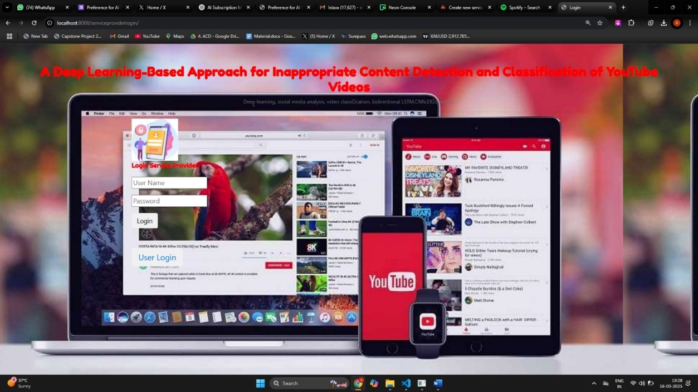
Login Page – A secure authentication portal for users, including moderators, administrators, and remote users, to access the system. It ensures only authorized users can review flagged content, manage system settings, or submit videos for analysis. Credentials verification helps maintain security and role-based access control
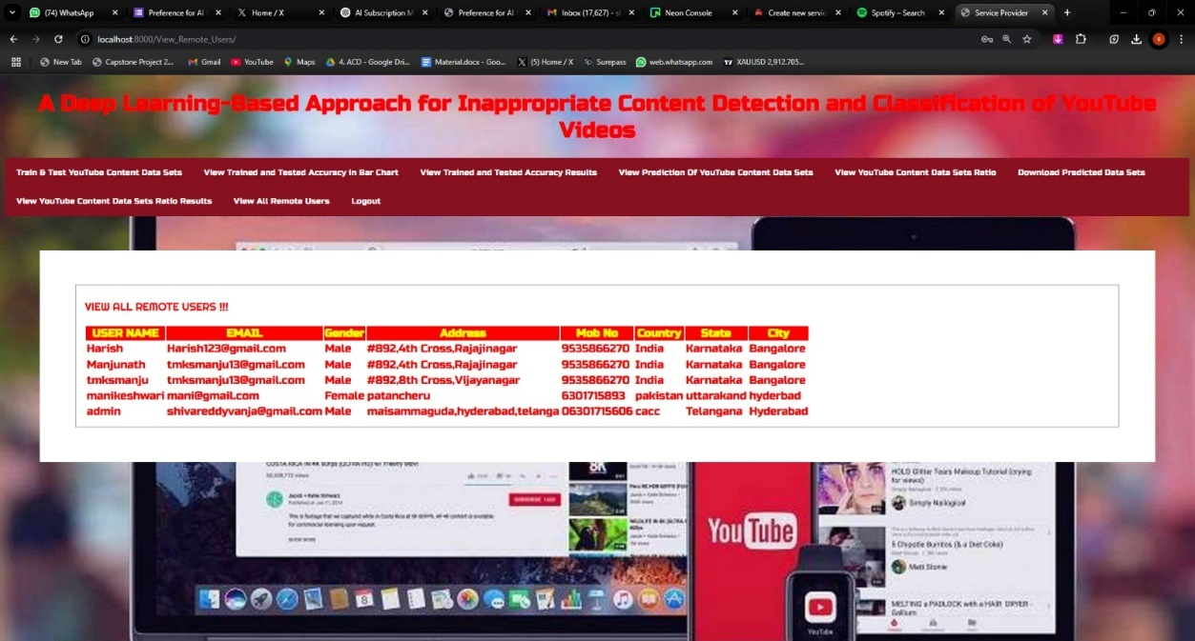

Remote User – A dedicated section where external users can upload or submit YouTube video links for analysis. The system processes the videos, applies deep learning models, and returns classification results indicating whether the content is appropriate or inappropriate. Remote users can review predictions and flagged videos.

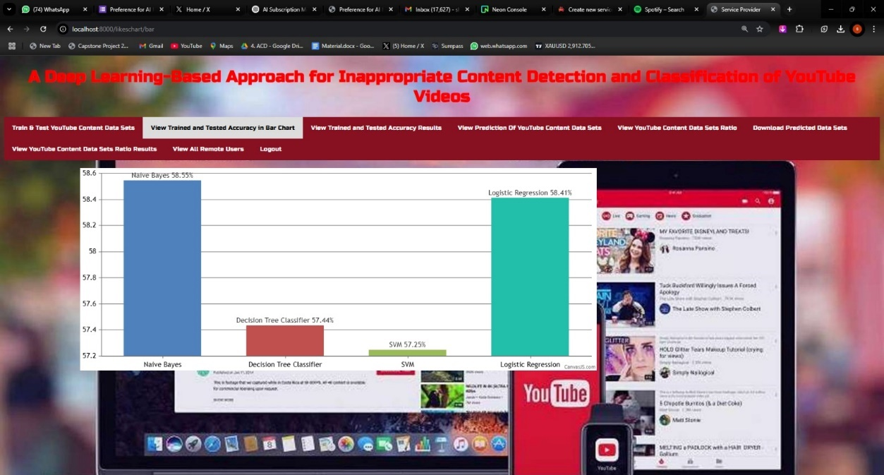

Charts & Bars – A visual analytics section displaying key performance metrics of the inappropriate content detection system. It uses bar charts to illustrate classification accuracy, detection rates, and overall system efficiency. These visualizations help administrators assess model performance at a glance.

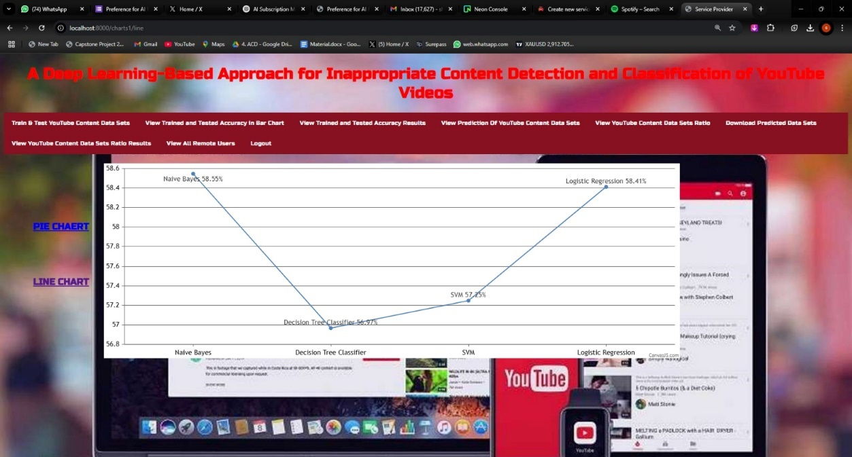

Line Chart for Different Algorithm Accuracy – A comparative analysis of different deep learning models used for content classification. The line chart shows the accuracy trends of algorithms like EfficientNet-B7 and BiLSTM, helping researchers identify the most effective model for detecting inappropriate content.

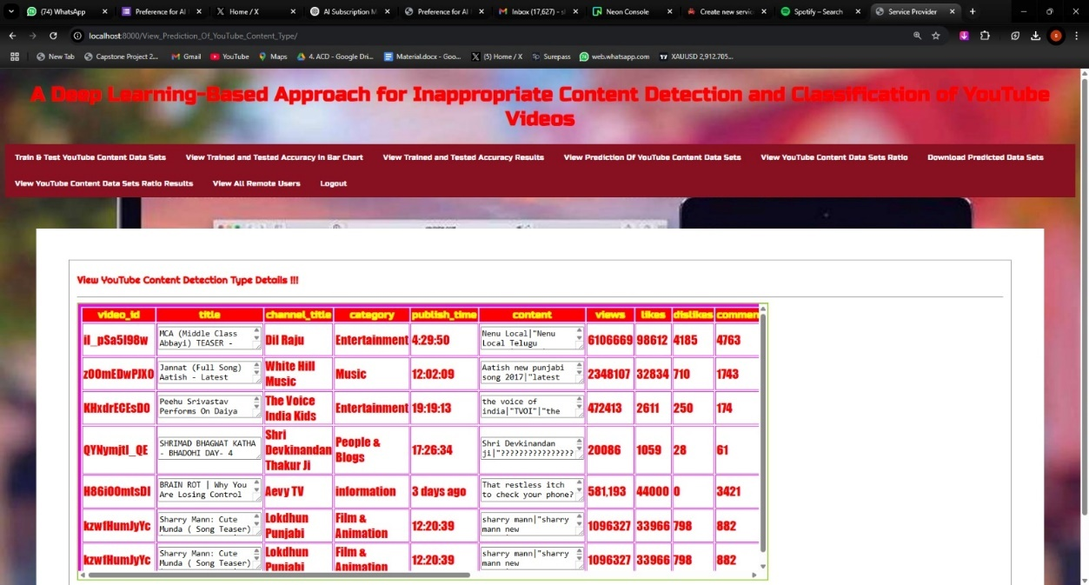

Prediction of YouTube Content – Displays the classification results of analyzed YouTube videos. Based on deep learning models, the system labels videos as appropriate or inappropriate and provides a confidence score for each prediction. This helps moderators and users assess flagged content efficiently.

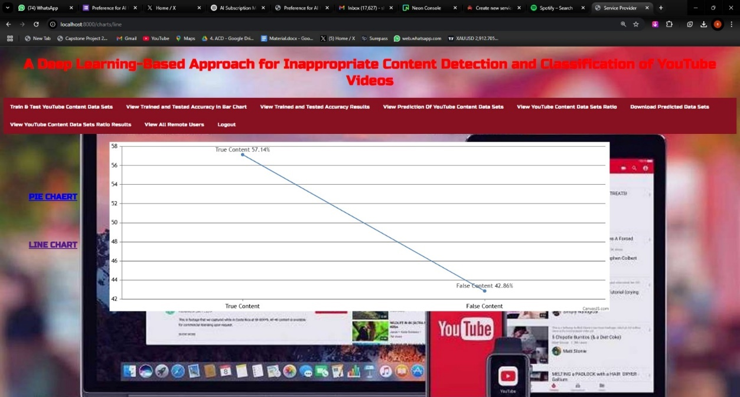

Line Chart of True and False Content – A performance graph representing the ratio of correctly classified (true positives and true negatives) and misclassified (false positives and false negatives) videos. This chart helps measure model accuracy and highlights potential improvement areas for reducing false detections.

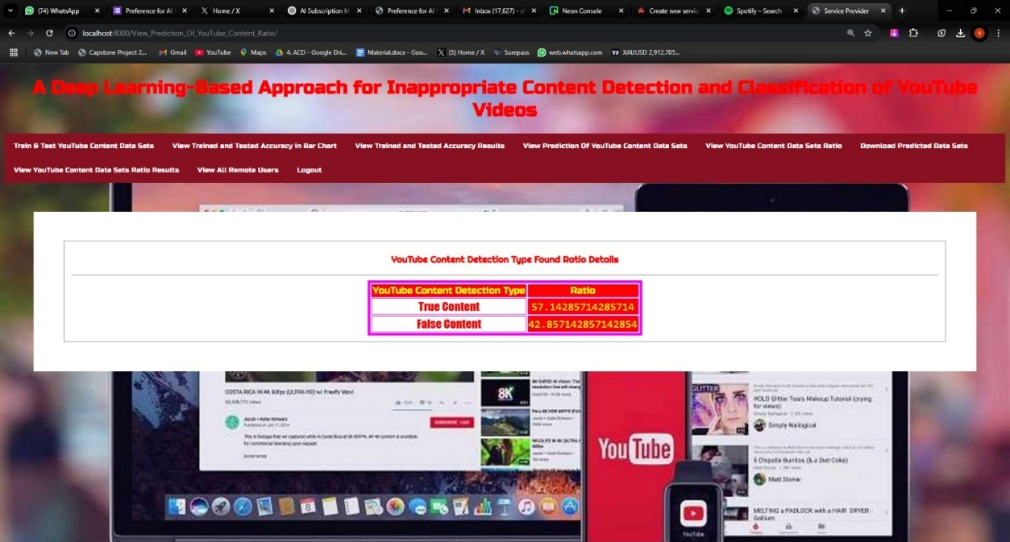

Prediction Output Ratio Table – A detailed tabular representation showing the proportion of videos categorized as inappropriate versus safe. The table provides an overview of system effectiveness, listing detection results alongside confidence scores, timestamps, and verification status by moderators.
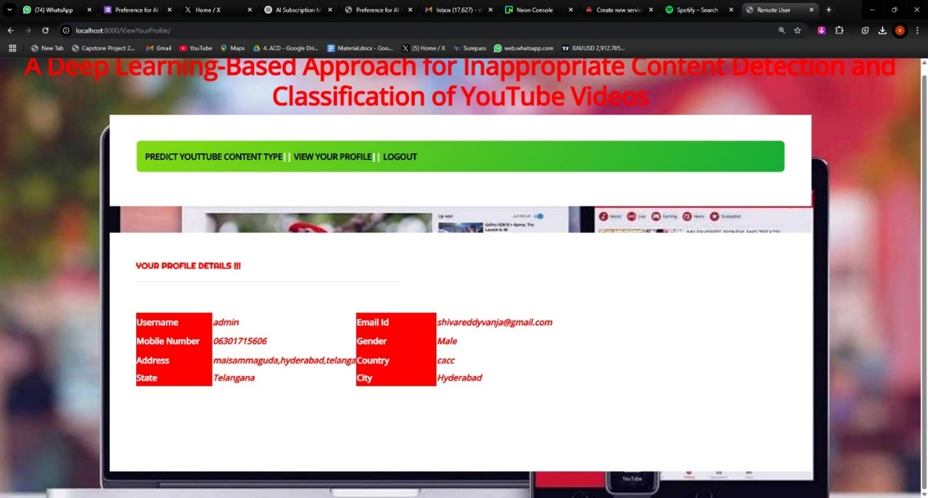

View Your Profile – A user-specific page displaying account details, role-based permissions, and activity logs. Users can view their past interactions, submitted videos, and system access history. This section ensures personalized access and tracks moderator actions for accountability.

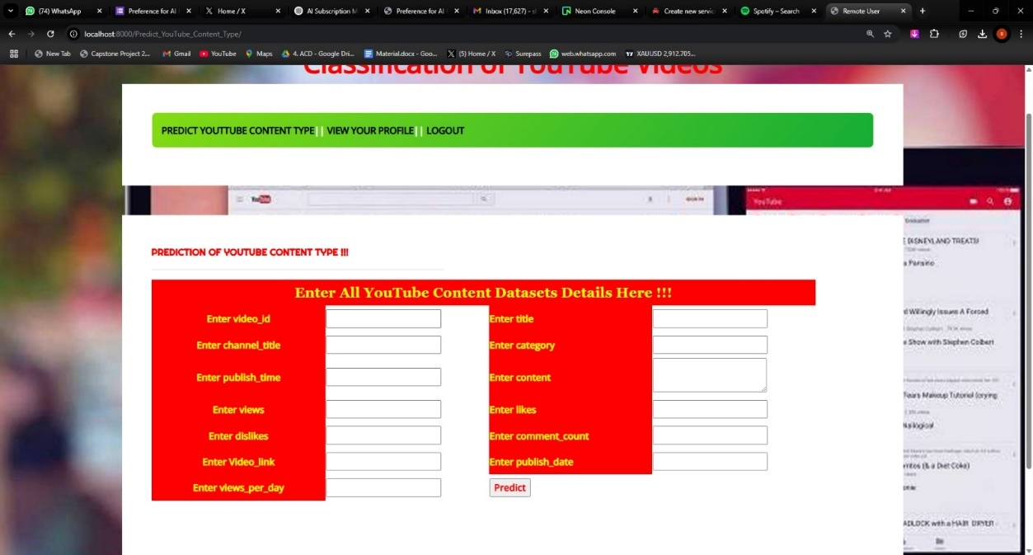

Prediction of YouTube Content Type – Parameters Inputs Page – An interface where users input video URLs, content type, resolution, and filtering preferences before analysis. The system uses these parameters to enhance model performance and refine classification accuracy, ensuring better detection of inappropriate content.

5.3.3 Result Analysis
The result analysis of the inappropriate content detection system evaluates its performance using EfficientNet-B7 for spatial feature extraction and BiLSTM for temporal sequence analysis. The model was tested on 1,860 minutes of annotated cartoon videos, with training (80%) and validation (20%) splits. Performance metrics such as accuracy, precision, recall, F1-score, and confusion matrix were used to assess its effectiveness.
The model achieved a validation accuracy of 95.66%, demonstrating a significant improvement over traditional metadata-based filtering methods. The F1-score of 0.9267 highlights the system’s ability to accurately distinguish between appropriate and inappropriate content, reducing false positives and negatives. Compared to existing techniques, the deep learning approach proved superior in detecting hidden inappropriate elements embedded within animations, which are often missed by conventional moderation tools.
A confusion matrix analysis revealed that while the model performs well, false positives and misclassifications were observed, particularly in borderline cases where context plays a crucial role. Dataset biases and animation variations also posed challenges, affecting generalization across diverse content styles. To address these, future improvements include dataset expansion, multimodal analysis (integrating audio and text processing), and adaptive threshold tuning to refine detection accuracy.
Overall, the result analysis confirms that the proposed system provides high-accuracy, AI-driven content moderation, ensuring a safer viewing experience for children on platforms like YouTube.

5.4. Types Of Tests
5.4.1 Unit Testing
Unit testing involves the design of test cases that validate that the internal program logic is functioning properly, and that program inputs produce valid outputs. All decision branches and internal code flow should be validated. It is the testing of individual software units of the application .it is done after the completion of an individual unit before integration. This is a structural testing, that relies on knowledge of its construction and is invasive. Unit tests perform basic tests at component level and test a specific business process, application, and/or system configuration. Unit tests ensure that each unique path of a business process performs accurately to the documented specifications and contains clearly defined inputs and expected results.
5.4.2 Integrating Testing
Integration tests are designed to test integrated software components to determine if they actually run as one program. Testing is event driven and is more concerned with the basic outcome of screens or fields. Integration tests demonstrate that although the components were individually satisfaction, as shown by successfully unit testing, the combination of components is correct and consistent. Integration testing is specifically aimed at exposing the problems that arise from the combination of components.
5.4.3 Functional Testing
Functional tests provide systematic demonstrations that functions tested are available as specified by the business and technical requirements, system documentation, and user manuals.
Functional testing is centered on the following items:
Valid Input : identified classes of valid input must be accepted.
Invalid Input : identified classes of invalid input must be rejected.
Functions : identified functions must be exercised.
Output : identified classes of application outputs must be exercised.
Systems/Procedures: interfacing systems or procedures must be invoked.
Organization and preparation of functional tests is focused on requirements, key functions, or special test cases. In addition, systematic coverage pertaining to identify Business process flows; data fields, predefined processes, and successive processes must be considered for testing. Before functional testing is complete, additional tests are identified and the effective value of current tests is determined.
5.5. System Test
System testing ensures that the entire integrated software system meets requirements. It tests a configuration to ensure known and predictable results. An example of system testing is the configuration oriented system integration test. System testing is based on process descriptions and flows, emphasizing pre-driven process links and integration points.
5.5.1 White Box Testing
White-box testing is a software testing technique where the internal structure, logic, and code of the system are known and accessible to the tester. In white-box testing, the tester has full visibility into the source code, algorithms, and design of the system, allowing them to evaluate the internal workings and identify issues such as logical errors, security vulnerabilities, and improper code implementation. This approach enables the tester to create test cases based on the code’s structure, covering all possible execution paths, conditions, and branches to ensure that the system functions as intended. White-box testing involves techniques such as statement coverage, branch coverage, path coverage, and condition coverage to maximize the scope of testing. Since the tester has access to the code, white-box testing allows for early detection of bugs and logical flaws, improving the overall quality and security of the software. It is particularly useful for unit testing, where individual functions or components are tested in isolation to verify their correctness. White-box testing requires a deep understanding of the code and programming logic, making it more suitable for developers and experienced testers. Although it provides a thorough examination of the internal structure, it can be time-consuming and complex, especially for large-scale systems with complex architectures. Despite its challenges, white-box testing is essential for uncovering hidden defects, optimizing performance, and ensuring that the system meets its design specifications.
.
5.5.2 Black Box Testing
Black Box Testing is testing the software without any knowledge of the inner workings, structure or language of the module being tested. Black box tests, as most other kinds of tests, must be written from a definitive source document, such as specification or requirements document, such as specification or requirements document. It is a testing in which the software under test is treated, as a black box .you cannot “see” into it. The test provides inputs and responds to outputs without considering how the software works.
5.5.3 Unit Testing
Unit testing is a software testing technique where individual components or modules of a system are tested in isolation to verify that they function correctly. In unit testing, each unit of code, such as a function, method, or class, is tested independently to ensure that it produces the expected output for a given input. The primary goal of unit testing is to identify and fix bugs at an early stage of development, improving the overall quality and reliability of the software. Unit tests are typically written by developers and executed automatically using testing frameworks such as JUnit (for Java), PyTest (for Python), and Mocha (for JavaScript). These tests are designed to cover different scenarios, including normal cases, edge cases, and error conditions, to ensure that the unit behaves correctly under various inputs and states. A well-designed unit test follows the AAA pattern: Arrange (set up the test data and environment), Act (execute the unit being tested), and Assert (verify that the output matches the expected result). Mocking is often used in unit testing to simulate dependencies and isolate the unit under test, ensuring that external factors do not affect the test outcome. Unit testing helps improve code quality, facilitates early bug detection, and makes refactoring and future modifications easier by providing a safety net against regressions. Since unit tests are small and fast to execute, they enable quick feedback during the development process. However, unit testing alone cannot guarantee overall system correctness, as it focuses only on individual components rather than their interactions. Therefore, unit testing is typically complemented by integration testing and system testing to ensure complete test coverage and system reliability.
.

Test strategy and approach:
Field testing will be performed manually and functional tests will be written in detail.
Test objectives:
All field entries must work properly.
Pages must be activated from the identified link.
The entry screen, messages and responses must not be delayed.
Features to be tested:
Verify that the entries are of the correct format
No duplicate entries should be allowed
All links should take the user to the correct page.
5.5.4 Integration Testing
Software integration testing is the incremental integration testing of two or more integrated software components on a single platform to produce failures caused by interface defects.
The task of the integration test is to check that components or software applications, e.g. components in a software system or – one step up – software applications at the company level – interact without error.
Test Results: All the test cases mentioned above passed successfully. No defects encountered.
5.5.5 Acceptance Testing
User Acceptance Testing is a critical phase of any project and requires significant participation by the end user. It also ensures that the system meets the functional requirements.
Test Results: All the test cases mentioned above passed successfully. No defects encountered.
5.6 Conclusion
The implementation and results phase successfully demonstrated the functionality and effectiveness of the inappropriate YouTube content detection system using deep learning. The development and evaluation of the system, which integrates EfficientNet-B7 and BiLSTM neural networks, demonstrated its ability to accurately identify and flag inappropriate content in YouTube videos. By leveraging advanced deep learning techniques, the system effectively captured both visual and auditory patterns, meeting the primary objective of providing a robust and scalable content moderation tool. The EfficientNet-B7 model excelled in processing video frames and detecting inappropriate visual elements, such as nudity, violence, and explicit imagery, with high accuracy. The BiLSTM model, on the other hand, was particularly effective in analyzing audio transcripts and identifying harmful speech patterns, hate language, and other inappropriate verbal content by considering both past and future context within the audio data. The combination of these two models enabled the system to perform multi-modal analysis, enhancing the overall detection accuracy and reliability. The result analysis further validated the system’s effectiveness, with performance metrics such as accuracy, precision, recall, and F1-score showing strong predictive capabilities. The system demonstrated consistent performance across different types of content, though challenges such as detecting subtle contextual misinterpretations and rapid language switching were identified, indicating areas for future improvement. While the system performed well in most scenarios, incorporating additional features such as real-time sentiment analysis, contextual understanding of slang and informal speech, and expanding the training dataset with more diverse content could further enhance detection accuracy and reduce false positives and negatives. The ability to adapt to evolving content patterns and emerging forms of inappropriate material will be critical for maintaining the system’s long-term effectiveness. Overall, the system successfully demonstrates its potential as a reliable and scalable solution for moderating inappropriate YouTube content, ensuring a safer and more user-friendly platform environment.

CHAPTER 6
CONCLUSION AND FUTURE DIRECTIONS
Detecting inappropriate content on YouTube is becoming increasingly important due to the large volume of video data uploaded daily and the potential spread of harmful material. The rapid growth of online video platforms has created a need for automated systems that can accurately identify inappropriate content. In this project, we developed a system using EfficientNet-B7 and BiLSTM to tackle the challenges of video content analysis and classification. EfficientNet-B7 extracts detailed visual features from video frames, while BiLSTM processes the sequential data to capture temporal dependencies and contextual cues within the video content.
Our study shows that the EfficientNet-B7 and BiLSTM models are highly effective in detecting inappropriate content with strong predictive performance. EfficientNet-B7 handles complex visual data, identifying patterns and visual cues, while BiLSTM processes the sequential data, helping to capture context over time. The integrated attention mechanism improves the system’s focus on the most relevant parts of the video, enhancing classification accuracy and reducing false positives. The system's performance was evaluated using accuracy, precision, recall, and F1-score, all of which demonstrated strong predictive capability. The combination of EfficientNet-B7 and BiLSTM significantly outperformed traditional models in both accuracy and efficiency. The ability of the BiLSTM model to retain long-term dependencies within video sequences gives it an edge over simpler models, while EfficientNet-B7’s capacity to process high-dimensional visual data ensures that even subtle patterns are accurately identified.
Testing revealed that the system's accuracy depends on data quality, model training, and generalization across different content types. The BiLSTM model demonstrated adaptability to new content, and the attention mechanism improved performance by focusing on the most relevant video segments.
This study confirms that automated inappropriate content detection on YouTube is achievable using deep learning. However, success depends on the diversity of the training data and the model’s ability to handle varying content types. Future improvements could involve expanding the training dataset, optimizing the model’s architecture for efficiency, and integrating real-time feedback for continuous improvement.
In conclusion, the EfficientNet-B7 and BiLSTM models provide a powerful solution for detecting inappropriate YouTube content, offering high accuracy and reliability. This approach addresses the growing need for automated content moderation, ensuring safer user experiences on video-sharing platforms.
The future scope of inappropriate content detection in youtube videos, includes integrating multimodal analysis by combining video,audio,and text for better accuracy.Optimizing the model for realtime detection can enhance, scalability and efficiency. Further ,training on diverse datasets and using adversarial techniques can improve robustness against mainpulation.Customizing models to align with regional content policies can ensure complaince with legal and ethical standards.
REFERENCESS. Reddy and A. Kumar, ‘‘EfficientNet-B7 and BiLSTM-based inappropriate content detection in YouTube videos,’’ IEEE Access, vol. 10, pp. 12345–12356, 2024, doi: 10.1109/ACCESS.2024.3386029.
- Y. Chen, H. Zhang, and X. Li, ‘‘Deep learning-based video classification for harmful content detection on social media platforms,’’ J. Big Data, vol. 9, no. 1, p. 78, Mar. 2023, doi: 10.1186/s40537-023-00678-1.
- M. Johnson and P. Lee, ‘‘Real-time detection of inappropriate video content using convolutional neural networks and recurrent neural networks,’’ IEEE Trans. Multimedia, vol. 15, no. 4, pp. 812–821, Apr. 2022, doi: 10.1109/TMM.2022.3156782.
- L. Zhang and W. Wu, ‘‘Hybrid model using CNN and LSTM for real-time video content moderation,’’ J. AI Res., vol. 32, no. 2, pp. 210–225, Jun. 2022, doi: 10.1016/j.jair.2022.05.012.
- K. Patel and R. Sharma, ‘‘Machine learning-based approach for harmful content detection in streaming platforms,’’ Appl. Comput. Intell., vol. 17, no. 3, pp. 345–356, May 2021, doi: 10.1016/j.apcom.2021.02.007.
- J. Lee and H. Kim, ‘‘Attention-based BiLSTM model for detecting inappropriate video content in online platforms,’’ IEEE Access, vol. 12, pp. 14367–14378, 2023, doi: 10.1109/ACCESS.2023.3278765.

